# Built-in types in C#

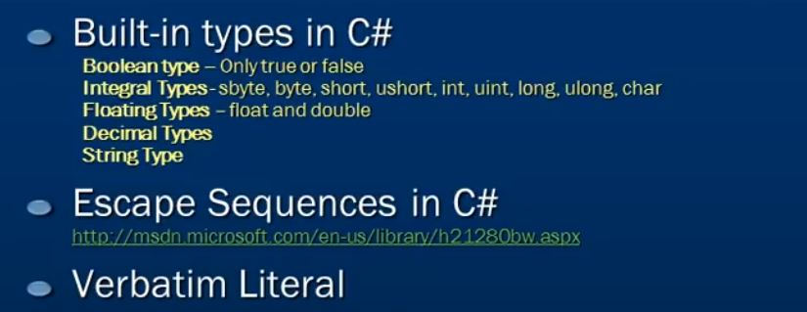

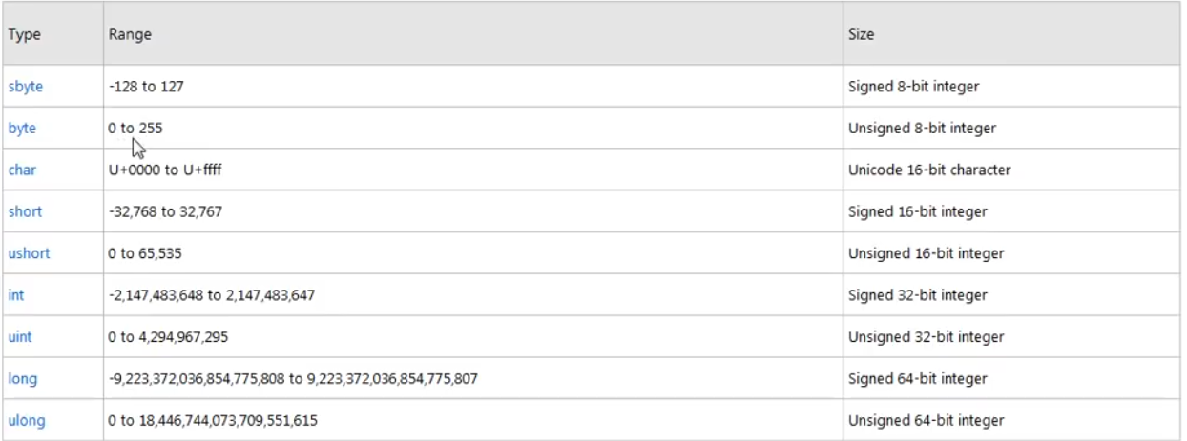

There is a formula to calculate the range.

A bit can have 2 values which are 0 and 1.

Sbyte and byte are 8 bit integers meaning that they can have 2^8 values which is equal to 255.

2 ^ 16 = 65536 and so on.

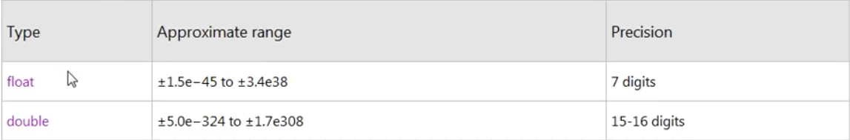

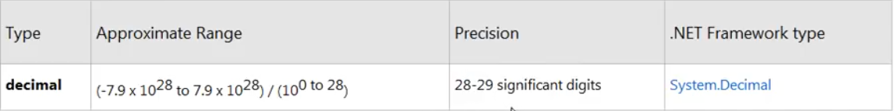

Strings are stored in double quotes in c#.

In C#, the escape sequence character is backslash. This can be used to escape any symbol character like “,/,<,> etc.

Different escape sequence characters in c#

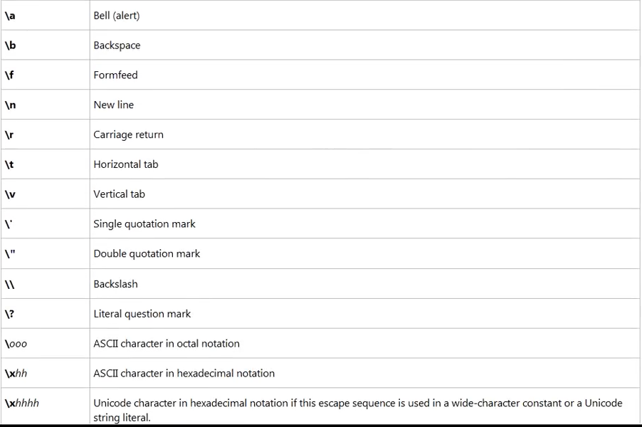



The path name above is not very readable. We can get rid of these by using the verbatim character of C#. “@” is called the verbatim character.

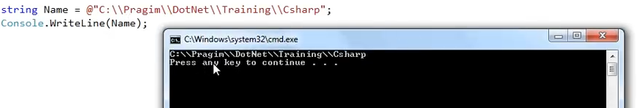

When you use @ in front of a string, every character inside the string is treated as printed character.

# Operators in C#

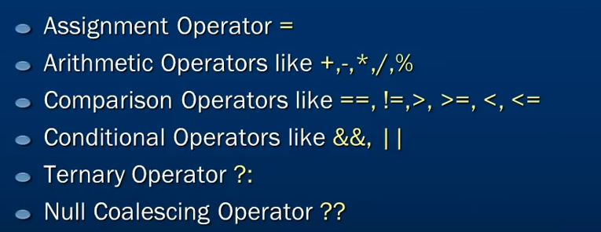



# Nullable types in C#

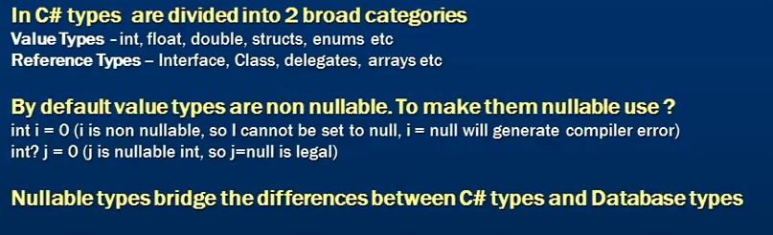

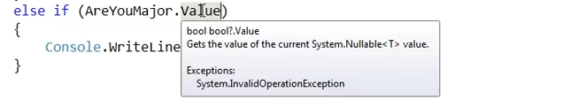

The .value property returns a Boolean datatype.

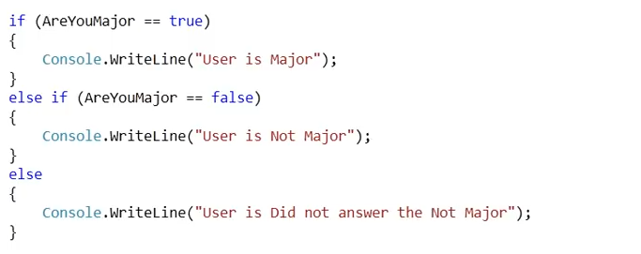

The else part here answers the scenario of null.

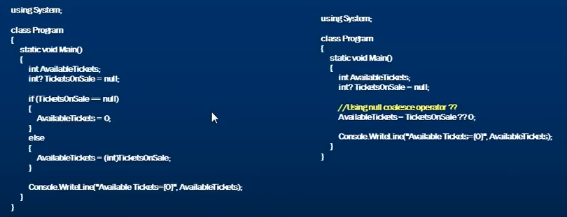

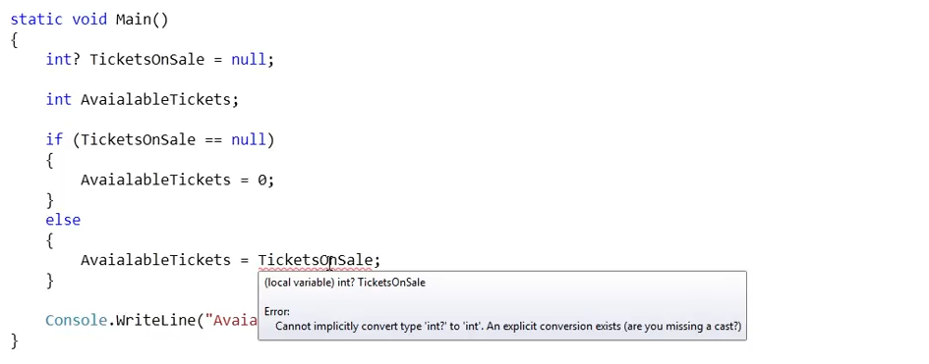

This is straight forward. If the value is not null then we are assigning it to the AvailableTickets int variable. But since this variable is not of nullable type, the compiler throws an error. This is because it cannot implicitly convert an int into nullable int.

To resolve this, there are many ways.

1. 

Notice that all we are doing here is that if the TicketsOn Sale has a value then use that value otherwise set the AvailableTickets to 0.

So, we can actually replace the if else block to something very simple using the Null coalescing operator.

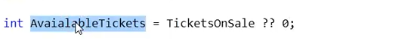

That’s it. It simply implies that if the value is null then use the default value 0 or else use its value.

# Datatype Conversions

int can be converted to float by c# mplicitly because int is much smaller then float.

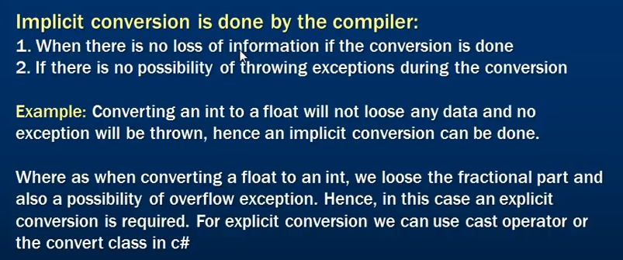

For explicit conversions, you can either use the typecast operator like (int) or the Convert class like Convert.ToInt32().

With typecast operator, if there is a chance of an exception to occur, then the exception will not be thrown. For example

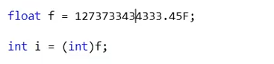

It is impossible for an int to hold this value. When we run this scenario, the output of I variable will be the smallest value of integer. No exception will be thrown.

But with the Convert class, we get an exception if any

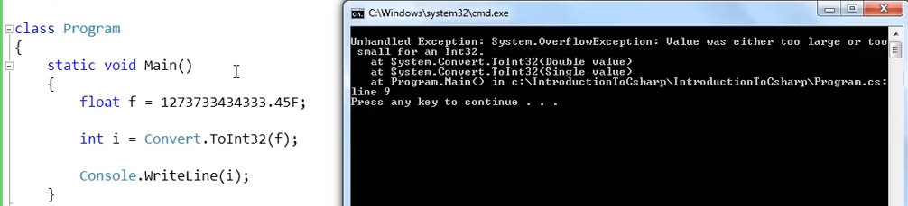

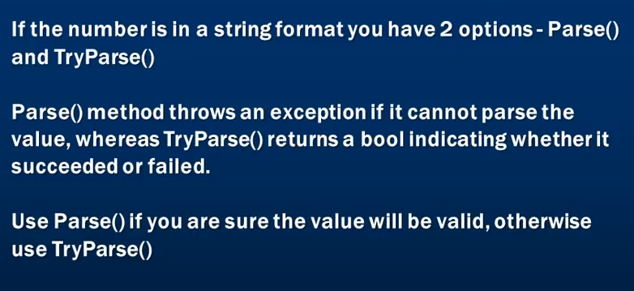

# switch vs if else

Prerequisite – [Switch Statement](https://www.geeksforgeeks.org/switch-statement-in-java/), [Decision making(if else)](https://www.geeksforgeeks.org/decision-making-javaif-else-switch-break-continue-jump/)  
A switch statement is usually more efficient than a set of nested ifs. Deciding whether to use if-then-else statements or a switch statement is based on readability and the expression that the statement is testing.

1. **Check the Testing Expression:** An if-then-else statement can test expressions based on ranges of values or conditions, whereas a switch statement tests expressions based only on a single integer, enumerated value, or String object.
2. **Switch better for Multi way branching:** When compiler compiles a switch statement, it will inspect each of the case constants and create a “jump table” that it will use for selecting the path of execution depending on the value of the expression. Therefore, if we need to select among a large group of values, a switch statement will run much faster than the equivalent logic coded using a sequence of if-elses. The compiler can do this because it knows that the case constants are all the same type and simply must be compared for equality with the switch expression, while in case of if expressions, the compiler has no such knowledge.
3. **if-else better for boolean values:**If-else conditional branches are great for variable conditions that result into a boolean, whereas switch statements are great for fixed data values.
4. **Speed:** A switch statement might prove to be faster than ifs provided number of cases are good. If there are only few cases, it might not effect the speed in any case. Prefer switch if the number of cases are more than 5 otherwise, you may use if-else too.  
   If a switch contains more than five items, it’s implemented using a lookup table or a hash list. This means that all items get the same access time, compared to a list of if:s where the last item takes much more time to reach as it has to evaluate every previous condition first.
5. **Clarity in readability:**A switch looks much cleaner when you have to combine cases. Ifs  are quite vulnerable to errors too. Missing an else statement can land you up in havoc. Adding/removing labels is also easier with a switch and makes your code significantly easier to change and maintain.

Lastly, implement whichever design is clearer and more maintainable as per the demand of your code. If you are landing in a huge switch-case or if-else block, switch to other techniques like polymorphism. Just find out the behavior of the object and try to encapsulate it if possible.

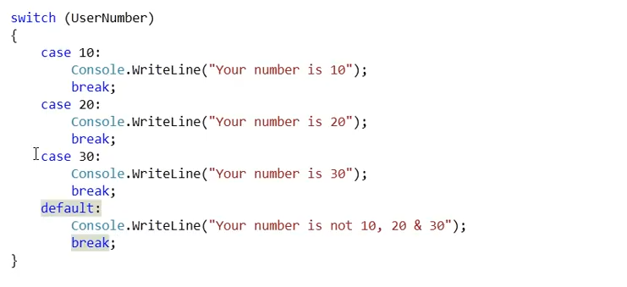

**Usage:** if the number of case is 5 or more, use switch case else use if-else block.

# Class

A class is a complex custom type datatype defined by user. It consists of data (state) and behaviour. Data is represented by its fields and behaviour is represented by methods.

Private Fields has a naming convention and starts with an underscore.

A constructor has the same name as that of the class and is used for initializing the required elements used in the class and its fields. A constructor does not return a value whereas a method can have a return type.

The “this” keyword when used in a class represents an instance of that class.

Destructors also has the same name as that of a class but they don’t take in any parameters. They cannot have return type and they start with tilde (~) sign.

Destructors are used to clean up all the resources the class was holding on to during its lifetime. These destructors are automatically called by the garbage collector when it tries to clean objects from the memory.

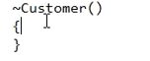

Dotnet provides a default parameter less constructor to the class if no explicit constructor is provided. Once the parametered constructor is provided to the class, the default parameter less constructor will be taken away by the .net.

If user intends to have a default parameter less constructor also, then it should also be declared within the class explicitly by the user.

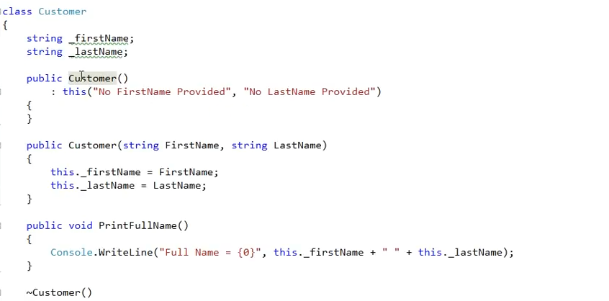

If you want your default constructor to call a parametered constructor then you can do it like above.

Constructors can be overloaded by the number and type of parameters.

# Static and Instance class members

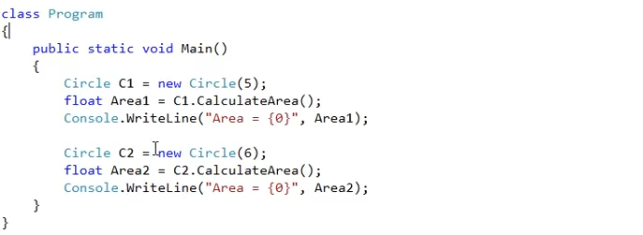

For Circle1 and circle2, what is the difference between the data it is carrying. The only difference is the radius. The pi value is always going to remain the same.

The value which is not going to change per object basis like Pi in this case can be made a static value.

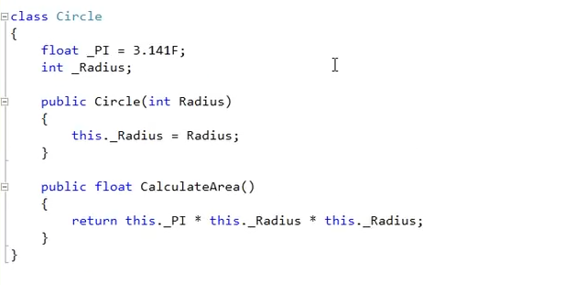

For now the PI is not a static field. So what happens is that, these fields are instance fields or on-static fields.

All the things that can be a part of class like properties, delegates, events, methods, fields etc can either be an instance/ non-static or static class members.

Static members has a static keyword in front of it.

For now as we know that the 2 fields are instance fields, whenever an object is created, the object will initialize both the fields even though the PI field value does not change. If we create 1000 objects, each object will have their own set of PI and radius field created in the memory.

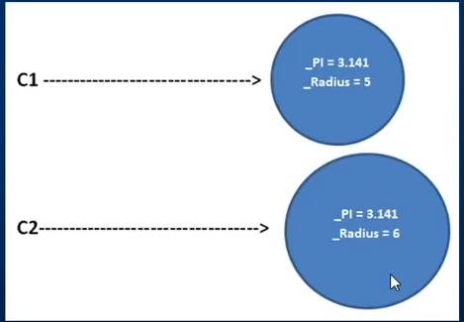

Since we know that the pi value is not going to change, it makes sense to mark it static. Marking it static will only instance the pi field once and there will be only 1 copy of Pi in the memory.

Anything that is not going to change per object basis needs to be marked static in order to have better memory and resource utilization.

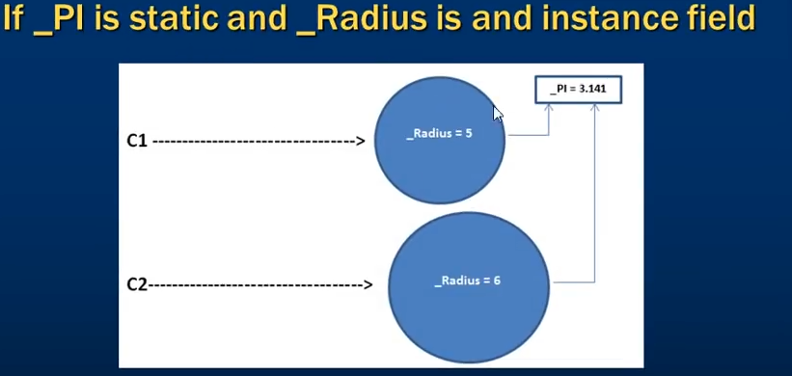

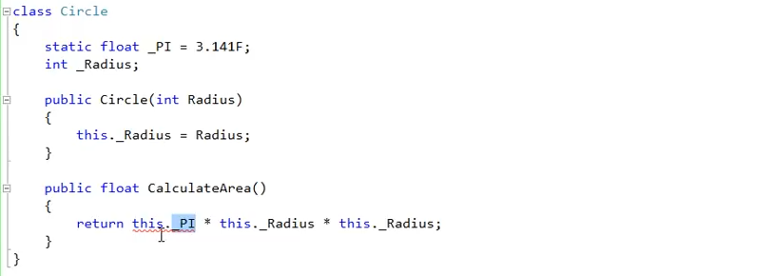

Notice the red line below the this.PI. this is an error.

This is because the moment we mark the pi field static, we cannot refer to the pi field with the this keyword. This is because, the “this” keyword to an instance of that class and since Pi is marked static and is not changing on per object basis, it cannot be part of the instance of the class now.

We can although call it by using the name of the class.

We don’t use an object to refer to a static member. It is wrong to say c1.Pi or c2.Pi where c1 and c2 are the circle class objects as pi is not changing.

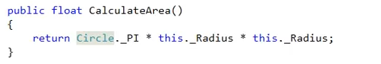

Static members are invoked using the name of the class and instance members are invoked using the instance object of the class.

Your constructor can also be a static constructor.

To initialize an instance field, we use instance constructor. Similarly, to initialize a static field, we can use static constructor.

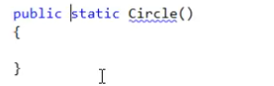

This is worng. Access modifiers like public and private etc are not allowed on static constructors.

**By default, if no access modifier is provided for a class member, they are private. If something is private, they can be accessed within the class they are declared in. And as all that is inside a class are called class members, it actually make sense to make them private by default as their general sense is that they needed to be used inside the class in which they are declared in.**

To make an instance of the class, we need to invoke the instance constructor. If the access modifier is removed from the constructor then the constructor is treated as private and is not visible outside the class. So no instance of that class can be created if that is the only constructor declared in the class.

Whenever we create an instance of a class, the constructor is automatically invoked. But a static constructor need not to be called. Anytime a field of the class is referred, the static constructor is called way before that to initialize the static field.

Since we cannot call the static constructors explicitly, .NET does not allow access modifiers for static constructors. Static constructors are called only once and always before any instance constructor of that class.

# Inheritance

Making your fields public is not at all suggested in real time. Instead we make our fields private and expose them to the external world as properties. Inheritance allows code reuse.

C# supports only single class inheritance whereas supports multiple interface inheritance.

Multilevel class inheritance is also allowed in C#.

Child class is a specialization of the base class.

Base classes are automatically instantiated before derived classes.

Parent class constructor executes before child class constructor.

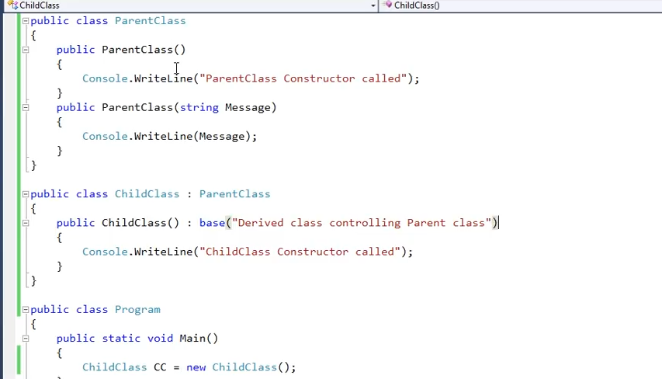

If you want that the parametered constructor is called when a child class object is created then you can control it using the base keyword.

# Method Hiding

If both the base and the derived class contains the method with the same name then the derived class method will hide the base class method.

We use the new keyword in the method name of the derived class to hide the base class member.

If for some reason we want to call the base class method then there are various ways.

1. 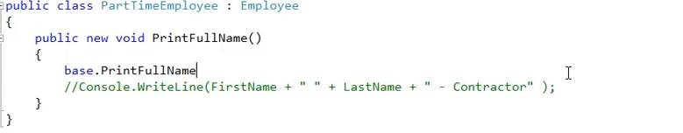
2. 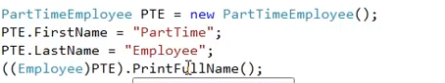
3. We can also do this by using the parent/base class reference variable.
4. 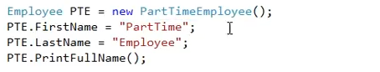

# Polymorphism

A parent class reference variable can point to a child class object forms the building block for polymorphism in c#.

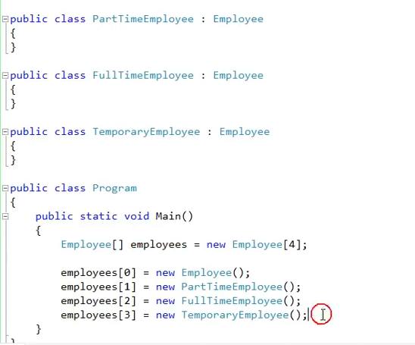

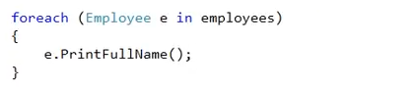

When we run this, the parent class PrintFullName method will be invoked as the child does not have this method.

Even if we implement these methods in the derived class, since our variable is of the base type the PrintFullName method that gets invoked is from the base class. The method hiding is there but due to parent class reference variable the base class method gets invoked.

If we want our derived class method to be invoked, we need to override the method implemented in the derived class. And in order to override the method in the derived class, we need to mark the method in the base class as virtual.

A method marked as virtual in the base class can be overridden in the child class if the child class wishes to do so. If they don’t override, the base virtual implementation will be available to the derived class.

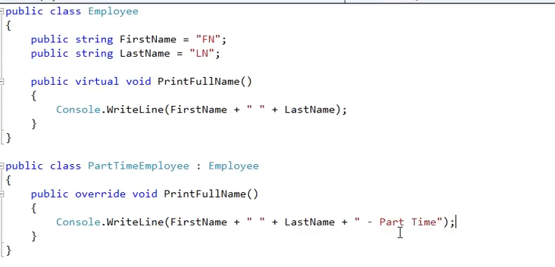

Polymorphism basically is a technique that enables you to call the derived class method even when you have the base type reference variable at runtime.

# Method Overriding v/s method overloading

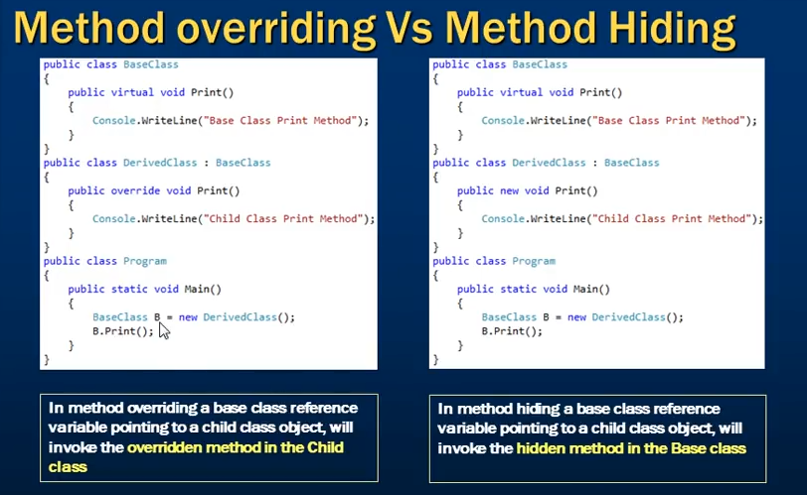

# Method overloading

This is also called as function overloading.

Methods with the same name and return type differing in the type and number of parameters is called method overloading.

A method can also be overloaded based on the kind of parameters.

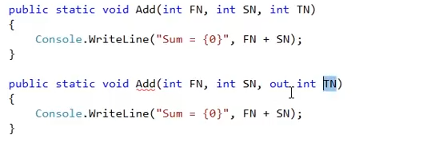

The kind of parameters is like the out, value type or reference parameter etc.

The return type and the params keyword cannot be used to overload a method. This is because the return type does not form the method signature.

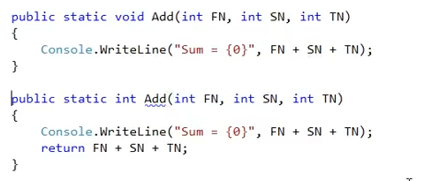

It is a compile time error to have methods with same name and no & type of parameters with just different return type.

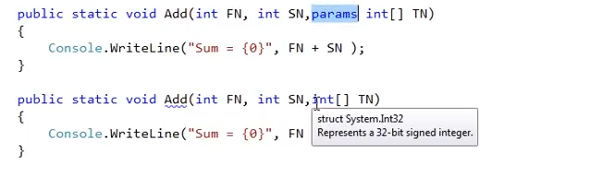

This is also a compile time error.

# Properties

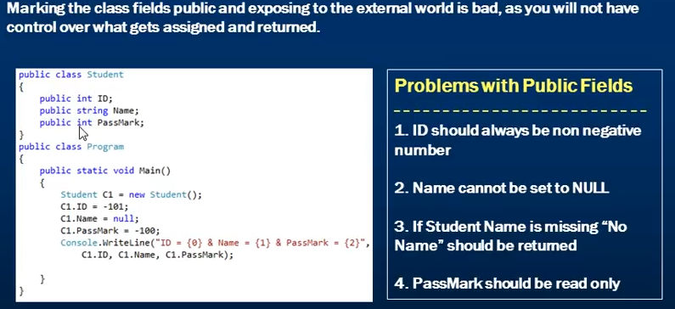

All the violations with the business rules are happening with the public class fields. To avoid these, we need to first mark these fields as private and should also have a mechanism to control what gets into the fields and what comes out.

Programming languages that doesn’t have properties, they used to use Getter and Setter methods to get and set the value of fields. this process is called encapsulation.

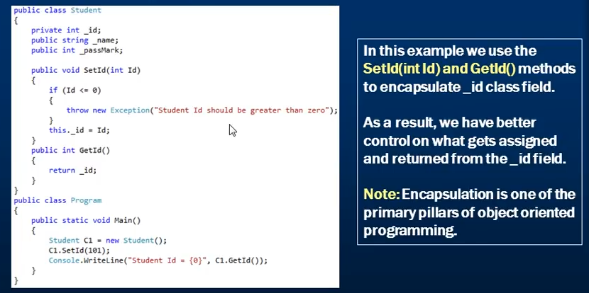

Properties in c# can be of three types. Read write, readonly and write only properties. Apart from these there are also auto implemented properties in c#.

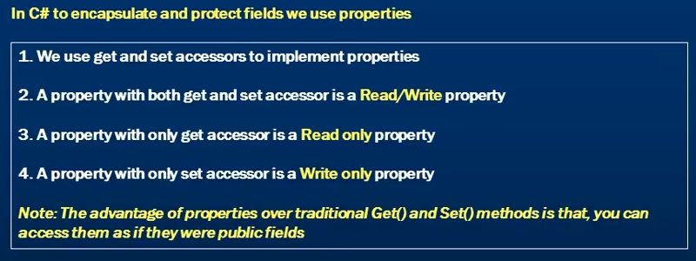

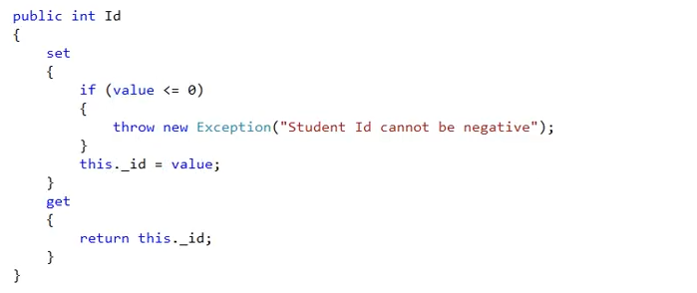

The value keyword is the one that will receive the value that we will set to the Id property.

If no additional logic is required in the get and set, we can make use of C# auto implemented properties.

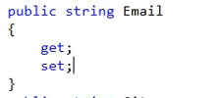

No need to create private fields and then set and return it in case of getter. The compiler will do that for us.

# Structs in C#

Just like classes structs can also have private fields, public properties, constructors, methods etc.

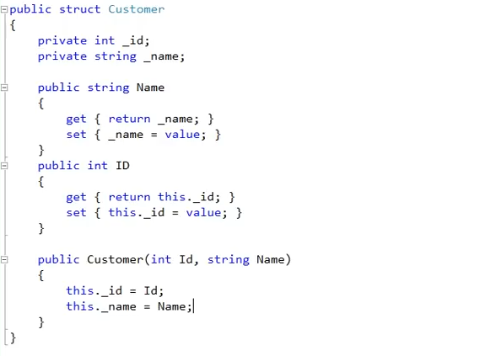

Looking at this, we can see that it is very similar to class and the only difference now is the use of struct keyword.

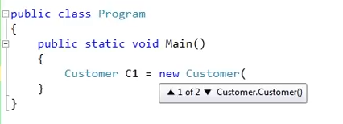

It is the same syntax that we use to create an instance of the class. The same syntax is used here and since Customer is a struct, we get an instance of struct.

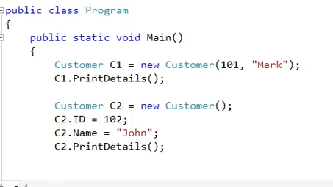

In first, we are using the constructor to initialize the fields but in the second we are first creating an object by using the default constructor and then using the public properties to initialize the fields.

Now, instead of doing all of these steps to initialize the fields we are doing in the second time, we can make use of object initializer syntax.

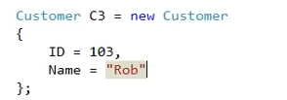

This is called object initializer syntax and have much less typing.

# Difference between classes and Structs

|  |  |
| --- | --- |
| **Structs** | **Classes** |
| Value type | Reference type |
| Stored on stack | Stored on heap |
| Holds value in memory | Holds a reference to an object in memory |
| Destroyed immediately after the scope is lost | Only the reference is destroyed after the scope is lost, the object is later destroyed by garbage collector. |
| A new copy of the struct gets created when you copy and modifications on one struct will not affect the value in other struct. | When we copy classes, we only copy the reference variable. Both the reference variable points to the same object on the heap so operations on one variable will affect the values contained by the other reference variable. |
| Can’t have destructors | Can have destructors |
| Struct can’t inherit from another class. | Can inherit from another class. |
| Cannot have explicit parameter less constructor | Can have parameter less constructor. |
| Struct are sealed types. Struct cannot inherit from another struct | Classes cannot inherit from struct as they are sealed types. |

Both struct and class can inherit from interface.

# Interfaces

Just like classes, it contains properties, methods, delegates or events, but only declaration and no implementation.

It cannot contain fields.

Interface members are public by default and does not allow any explicit access modifiers.

Interface can inherit from other interfaces. A class which inherits from this interface has to provide all implementation of all the interface members in the entire interface inheritance chain.

We cannot create an instance of an interface but an interface reference variable can point to a derived class object.

We cannot instantiate an interface because it does not contain implementation and so if an instance is created and the method is called, what will it do? So .Net does not allows to create an interface instance.

# Explicit interface implementation

If two interfaces have a method with the same name and return type and the class is inheriting from both of the interfaces, when providing implementation in the class, which interface implementation it actually is?

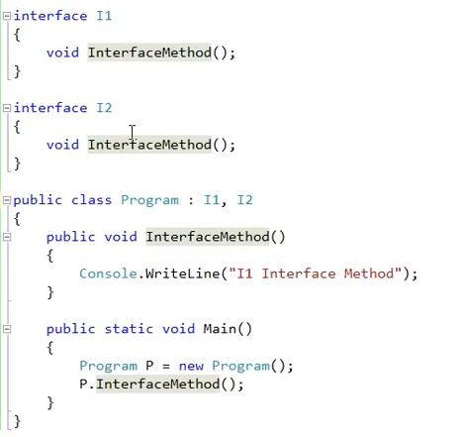

There is an ambuiguity. .Net thinks that the class has implemented both the interface methods. We don’t actually get any compile time error. This ambiguity can be resolved by using the explicit implementation.

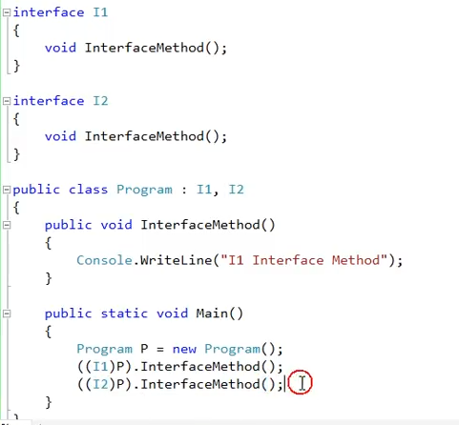

For now we have only one implementation so it still does not resolve our issue. The only way is to explicitly implement it.

While explicitly implementing any interface member

1. You are not allowed to have access modifier
2. You have to use the InterfaceName.MethodName convention.

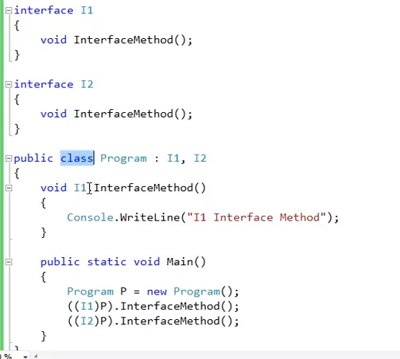

Once the interface member is explicitly implemented, you cannot use P.InterfaceMethod directly. Where P is a class instance. You need to type cast it into interface.

If we want to make any one of the interface implementation to be called by default if we call the interface method through an instance of class object, then implement that member normally and explicit implement the other one.

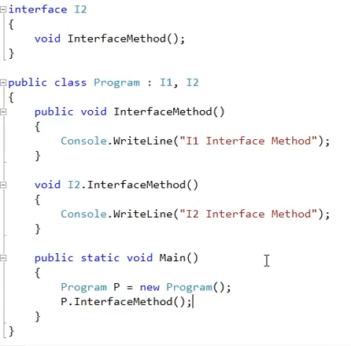

# Abstract classes in C#

Abstract keyword is used and since this class is incomplete, it can’t be instantiated. It can only be used as a base class.

It can never be marked as sealed as it needs to be inherited for its implementation. A sealed class cannot be inherited so this will make no sense to the abstraction.

An abstract class may contain abstract members (methods, properties, indexers and events) but not mandatory.

A non-abstract class inheriting from the abstract class need to provide the implementation for all the abstract members. If it does not wish to provide the implementation for all the abstract methods then it also needs to be marked as abstract.

The abstract class member can only contain declaration. Access modifier needs to be provided.

In order to provide the implementation, you have to override the abstract method by using the override keyword.

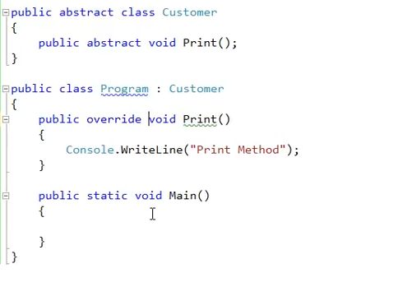

Abstract and Sealed contradict each other.

You cannot create an instance of an abstract class.

# Difference between abstract class and interface

|  |  |
| --- | --- |
| **Abstract Class** | **Interface** |
| Can have implementation for some of its members. | Can’t have any implementation |
| Can have fields | Cannot have fields |
| Can inherit from another abstract class and interface | Can only inherit from another interface. |
| Members Can have access modifiers | Members cannot have access modifiers |
|  |  |

# Problems with multiple class inheritance

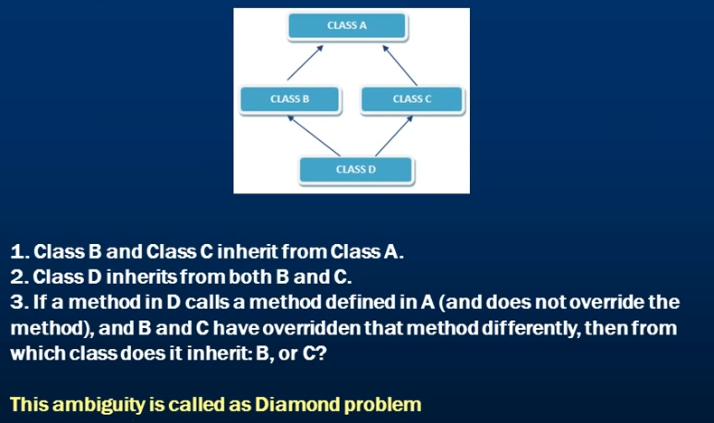

Class A has a virtual print method which is being overridden in class B and C implementation.

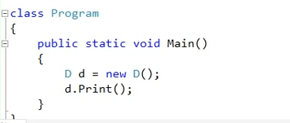

Now which Print method should be invoked. The one in B or the one in C.

# Multiple Class inheritance using interfaces

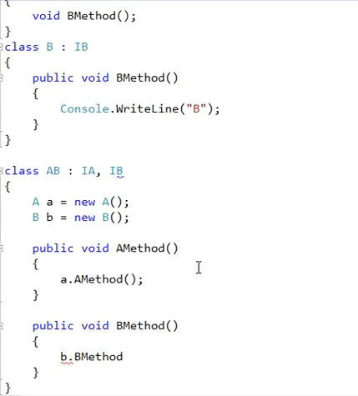

We have two interfaces IA and IB which are being implemented in class A and B respectively. Since class AB cannot inherit from A and B class at once, we can inherit it from IA and IB and then create an instance of both the classes A and B and call their implementations while implementing IA and IB in AB class.

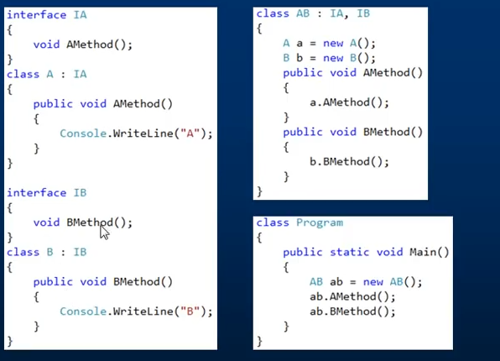

# Delegates

These are reference types.

A delegate is a type safe function pointer. It means that a delegate points to a function and when you invoke the delegate, the function will be invoked.

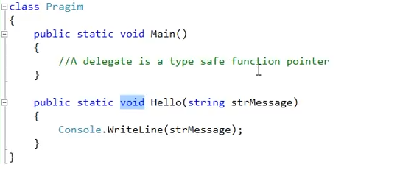

Now we have a method called Hello which returns void and takes in a string type parameter.

Since a delegate is a function pointer, like a method it also has a name, return type and parameter.



This delegate can now point to any function which takes in a string parameter and returns a void. If you closely look at the delegate, if we remove the delegate keyword, it seems to be actually a method signature.

To make the delegate point to a function, you have to create an instance of this delegate.



The intellisense says that the parameter you are going to pass should be a function name with a return type of void and taking in a string parameter. Since our method satisfies this, we can call our function through this delegate.

For invoking the method, you need to invoke this delegate. We can see from the syntax of the delegate that it is expecting a string parameter to be passed into it.

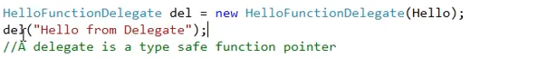

What will happen now is that the delegate will invoke the Hello method and pass the string value to the method as parameter and then the Hello method will do its job.

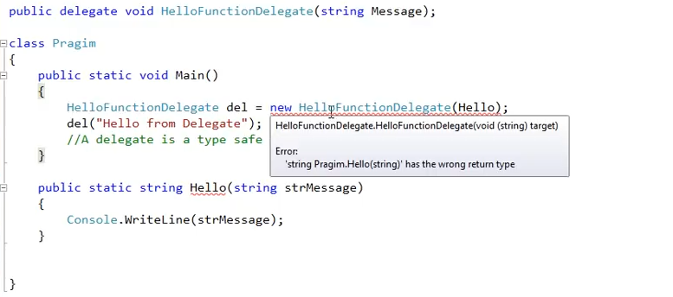

Now we have changed the return type of our hello method and we get a compile time error saying that the delegate is invoking a function/method with the wrong return type.

This is why delegate is called type safe as it cannot be used to call methods whose signature does not match to that of the delegate.

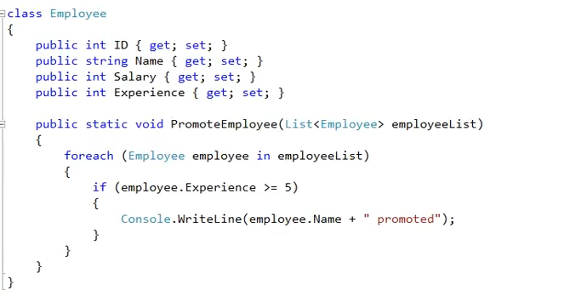

Here we have an Employee class that is promoting employees with an experience greater than 5. Now if, any other company takes code and want to use our PromoteEmployee method with some other criteria let’s say Salary or say want to promote employee greater than experience 3 years, then the company has to open the code and change it according to their needs.

This problem can be solved by using delegate. Delegates are extensively used by framework developers to plug the logic that developers want to into the framework methods.

We will now implement this class using delegate so that it can become reusable.

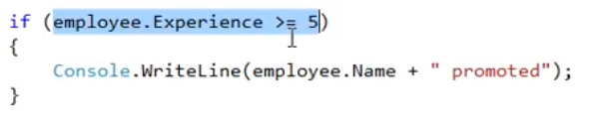

We want to replace this selected logic. Instead of hard coding this, we want to pass a method as a parameter in the selected code to make it dynamic.

Now this expression will either return a true or false. So while replacing this logic and making it dynamic, we want a delegate which should also return a true or false. So the return type of the delegate should be bool. Also the expression is making use of an employee object so we need to pass in an employee object as a parameter to the delegate.

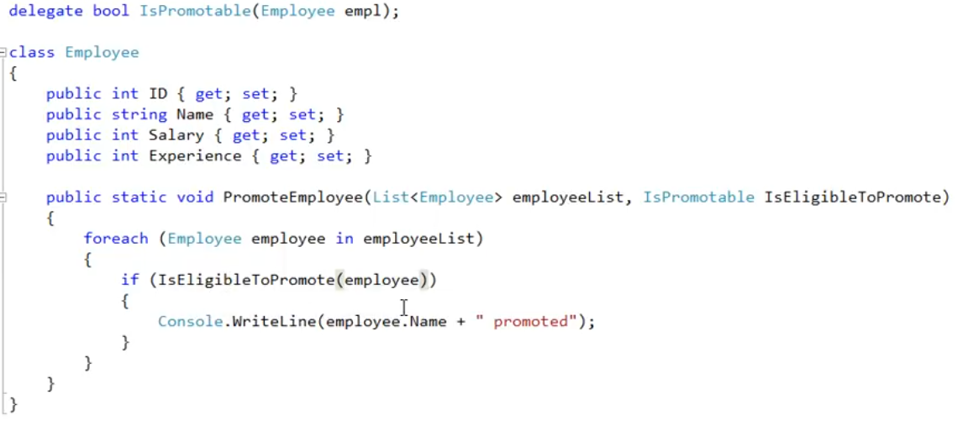

Now this is the changed code. We are passing the delegate as a parameter to the PromoteEmployee method. We know that a delegate is a function pointer so IsEligibleToPromote delegate should invoke a method that takes in an employee object and tells us whether the employee is eligible for promotion based on the method logic. Now this logic will be decided by the end user that is making use of our Employee class.

So when the end user is going to call the PromoteEmployee method, he/she is now going to pass in a delegate also apart from the employeeList.

Delegate behaves like a class, we instantiate a class, we can instantiate our delegate also.

Suppose in our program.cs file we are using the employee class. There now we can make use of this delegate logic and create our own Promote method to do the promotion for us instead of depending on the employee class logic.

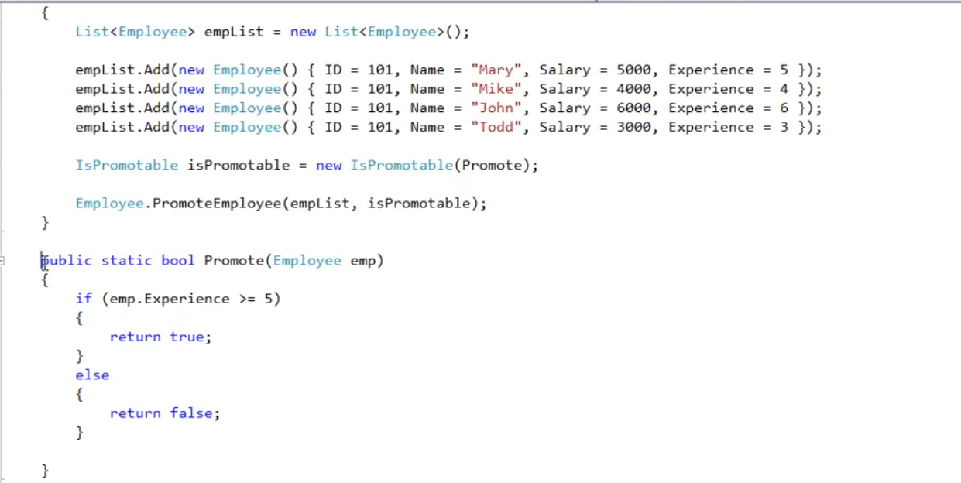

We can also get rid of the Promote method and the delegate instance and can make use of inline lambda expression to pass in our delegate condition. Lambda exp uses delegate internally to this will fulfil our needs.

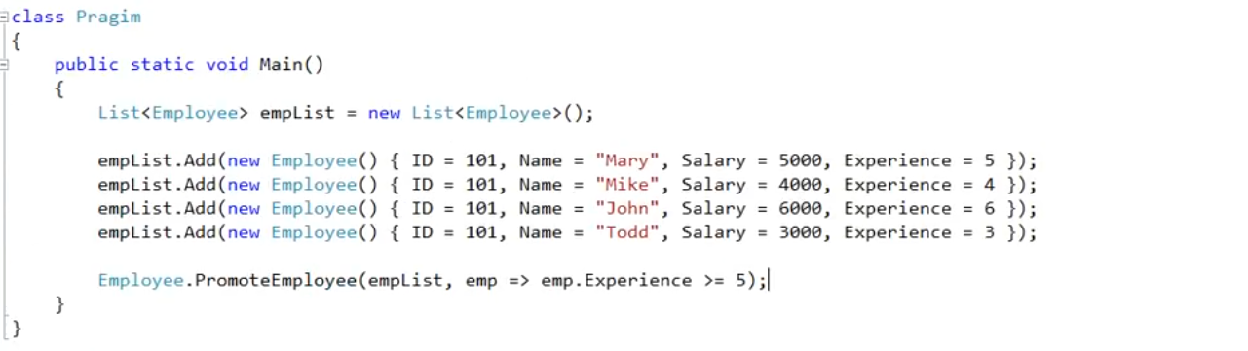

# Multicast Delegates

A delegate that has a reference to more than one function is called a multicast delegate. When you invoke the delegate, all the functions the delegate is pointing to gets invoked.

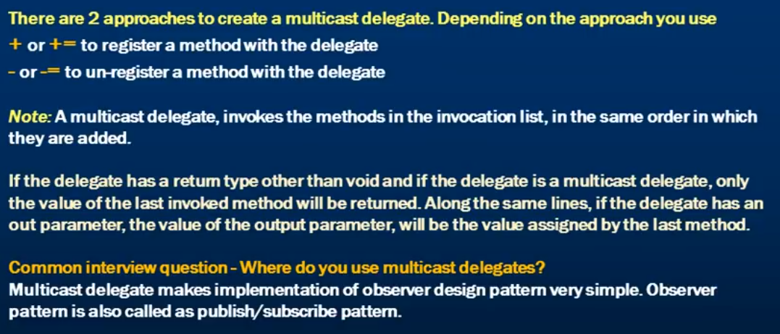

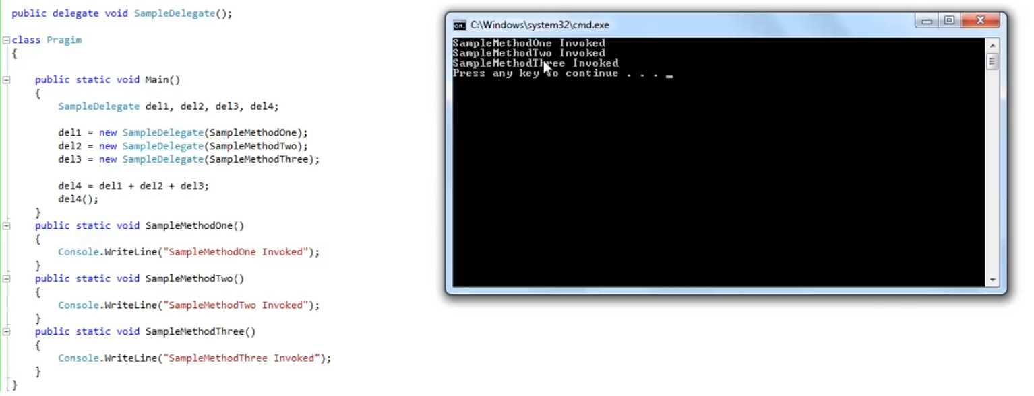

The first 3 delegate variables points to single function but delegate 4 variable points to all the three delegates variables.

This del4() is called a multicast delegate. By chaining the delegates together, we made del4 as multicast delegate.

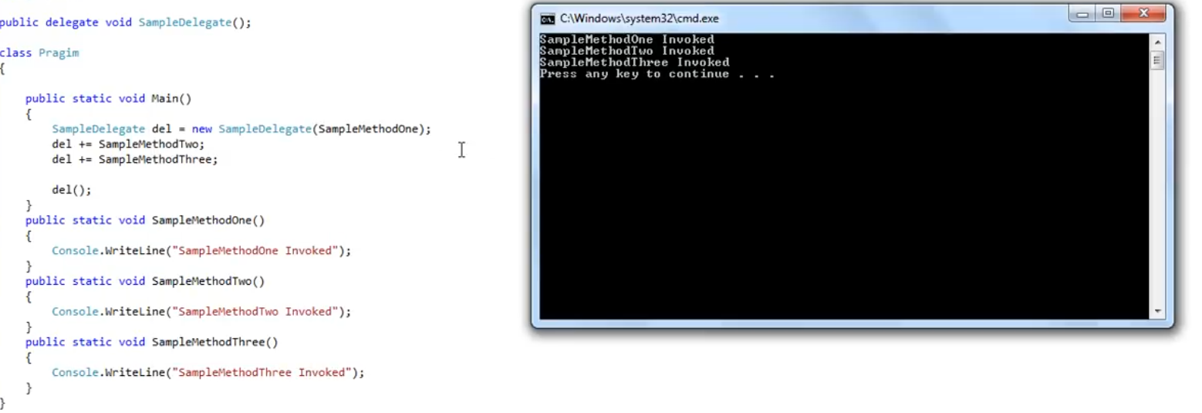

This is the another way to do it.

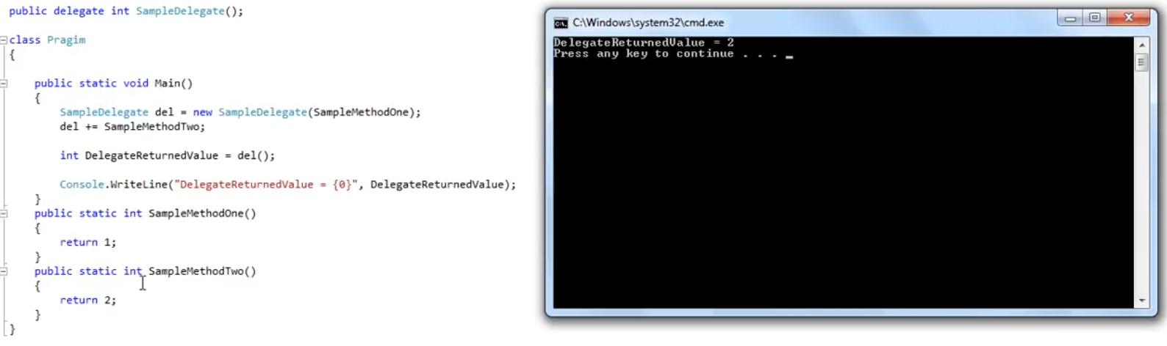

It only returns the value returned by the last function invoked.

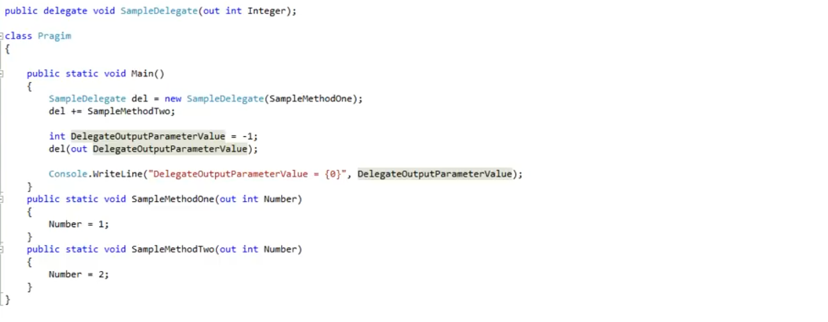

This will return the value 2 as the last value assigned to the Number parameter by the method is 2.

# Exception Handling

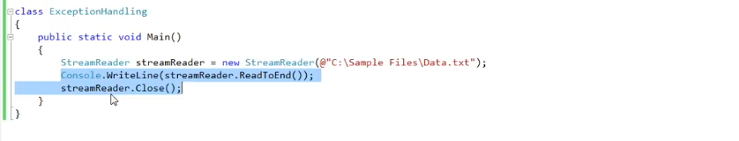

When an exception occurs while reading the file in the first line, the below 2 lines are skipped and the streamReader is never closed. So, the resources in these kinds of cases may not get release. That is why exception handling is a must.

We use try catch and finally block to handle the exception. Finally block is optional.

All .Net exceptions are directly or indirectly inherits from Exception class.

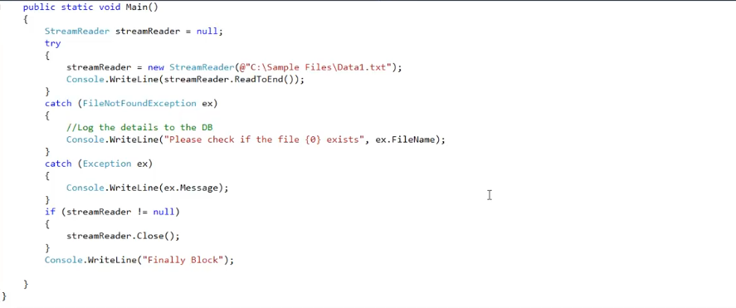

In the above case, the code below the last catch block will always be executed no matter exception occurs or not. So what do we need a finally block for.

We need finally block as if there is an exception in the catch block as this might happen because in the catch block we make logging in a file or DB, the resources will not be released. So it is always a good practice to have your cleanup code inside of a finally block.

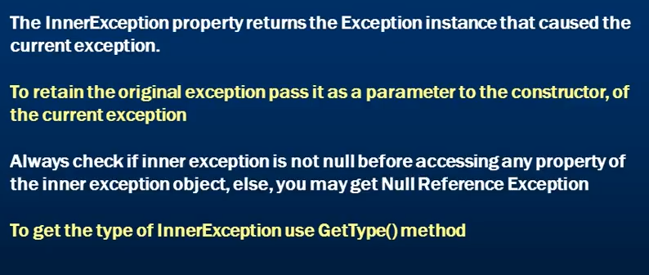

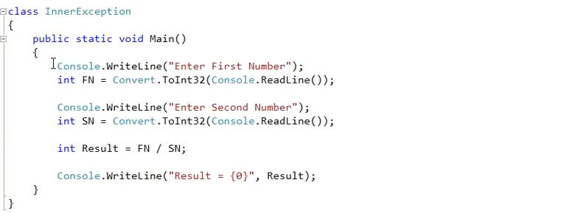

This program can fail due to many reasons.

1. The number entered is larger than what an integer can hold. Overflow Exception
2. Unable to convert the passed number to int. Format Exception
3. Divide by zero exception

What we want to do is to log the exception into a log file. We also want to log the type of exception.

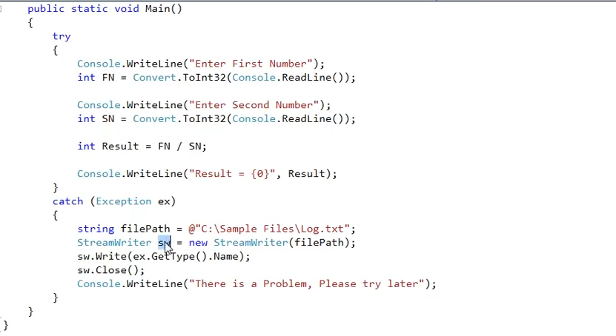

We get the type of the exception by using the GetType method. But what if this file is not present. We will get an exception in the catch block.

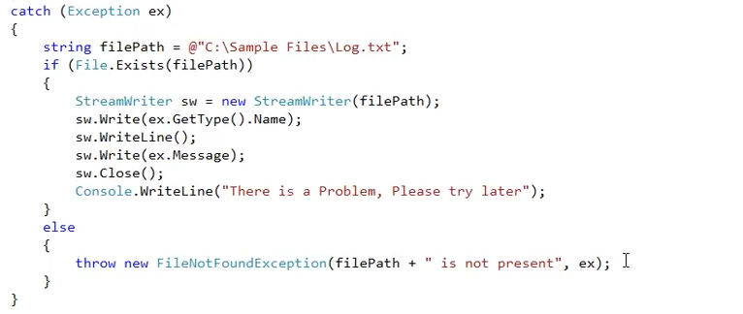

So, what we are doing is throwing an exception if the file is not present. In short, first we get an exception in our program which landed us in the catch block and in that block, if the file is not present we are throwing another exception. Now we don’t want to lose the original exception. If you want to retain the first exception then you pass that exception as a parameter to the constructor of the file not found exception class.

So, ex is our original exception and the fileNotFound is our current exception.

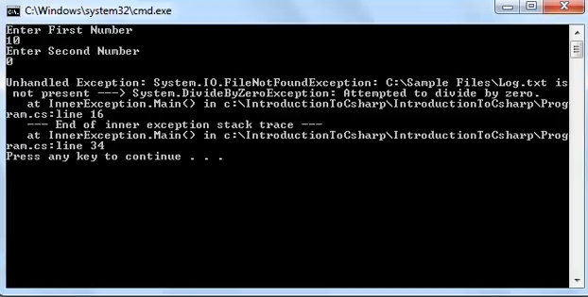

Now if you want to handle this exception then you have to wrap the entire code in another try catch block

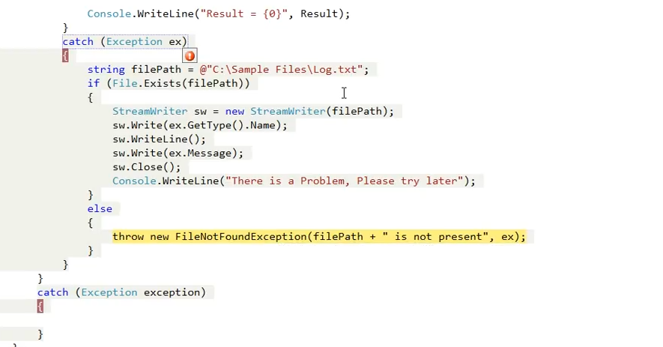

When the FileNOtFound exception is thrown and catched by the outer catch block, the exception variable will have the FileNotFound exception details and our original exception ex will be stored in the inner Exception part of the exception variable.

So our original exception is divideby zero will be present in the InnerException and the current exception can be seen directly

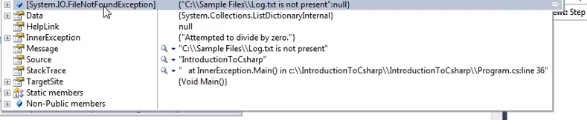

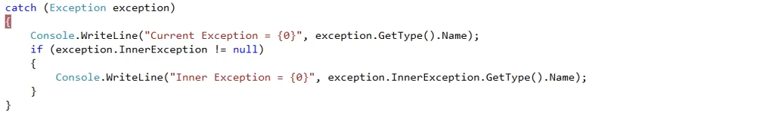

# Custom Exceptions

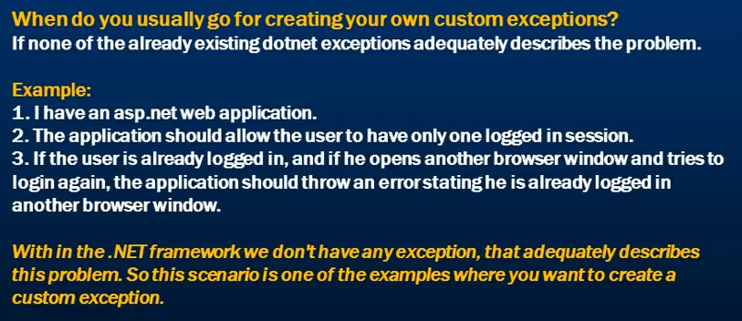

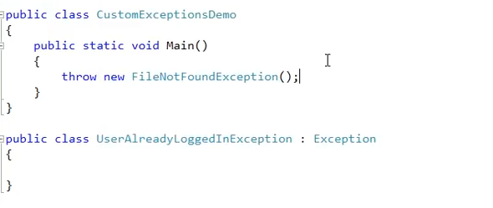

You create a class and inherit it from the system.Exception class. This is the first step for making a custom exception. Then as usual you can throw an exception of your class.

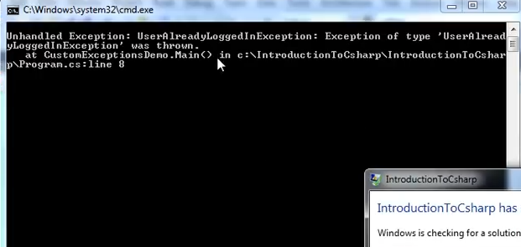

Since our exception class has no constructor, we cannot pass in our custom message when exception of our class occurs.

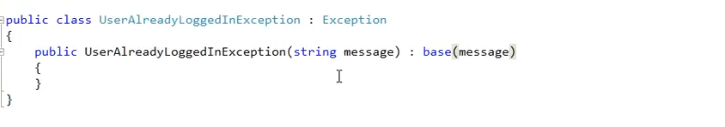

Now we have create a parameter constructor that takes in a message and we don’t have to provide the implementation as the base class Exception already has this constructor in it which takes in a message parameter.

All we need to do is to call the base class parameter constructor from our exception class parameter constructor.

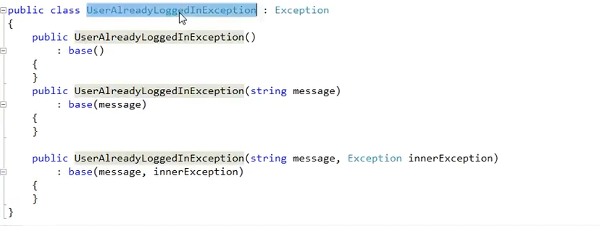

Now our exception class can handle the inner exception as well so that it can retain the original exception.

This class works only within the same application domain. If you have 2 different applications and they want to communicate to each other then the objects needs to be serializable before they can be shared between the 2 applications.

So if yo want to move your exception class to move from one application domain to another application domain then your custom exception class needs to be serializable.

To make your class so, you need to decorate it with the serializable attribute.

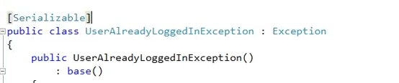

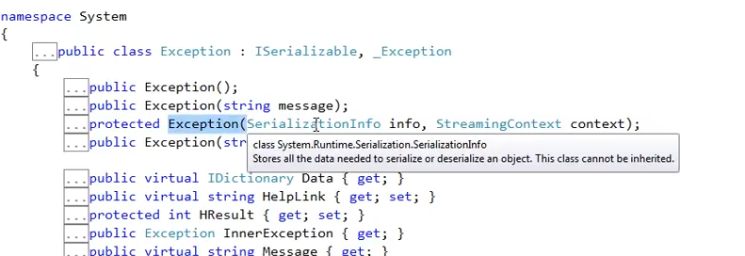

Now if you look at the base Exception class, it has a protected constructor that takes in a SerializableInfo and StreamingContext as parameters.

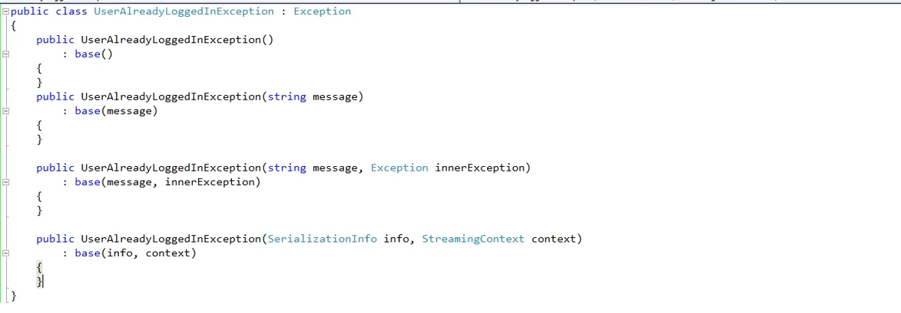

So now our custom exception class is almost equivalent to any other exception class in .net.

# Exception Handling Abuse

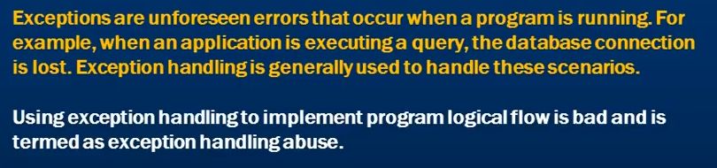

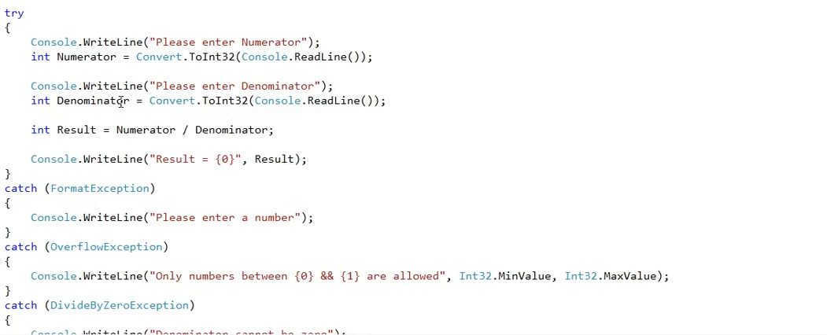

This is bad. Use TryParse instead of Convert.Int32 and avoid multiple catch block.

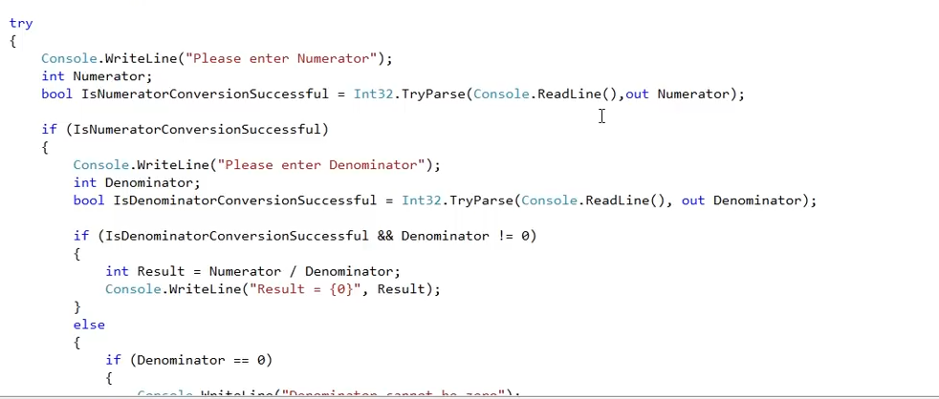

# Enums

These are strongly typed constants.

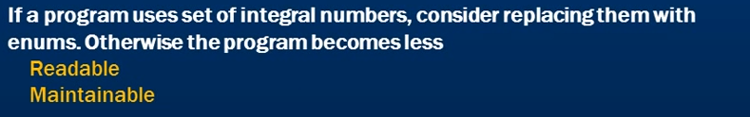

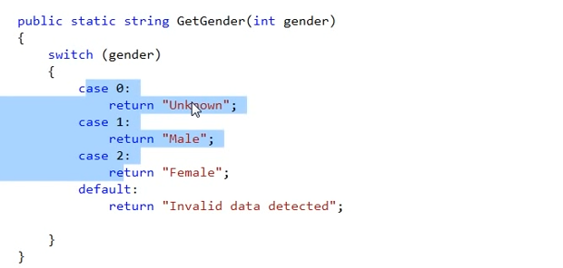

Use enum instead

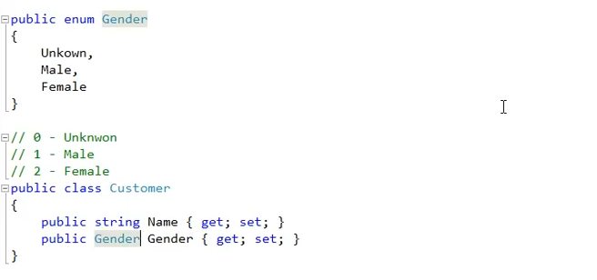

Now this is more readable

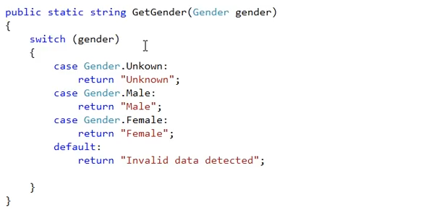

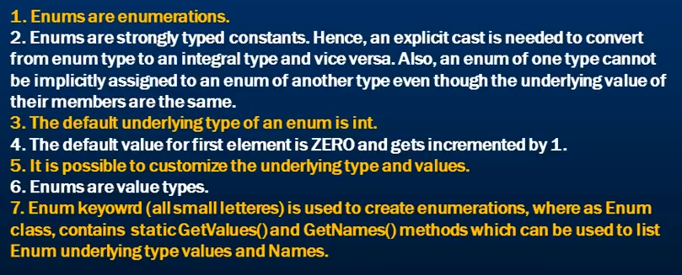

This is how you can change the underlying type from default int to short

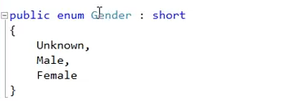

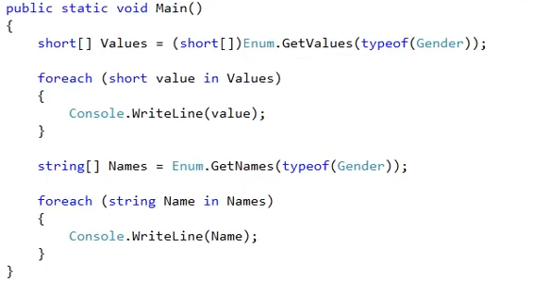

This is how you can convert a int value to the type Gender enum and vice-versa

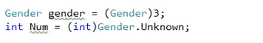

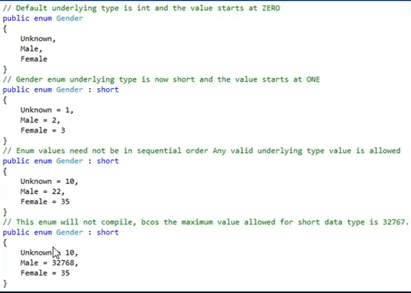

# Difference between types and type members

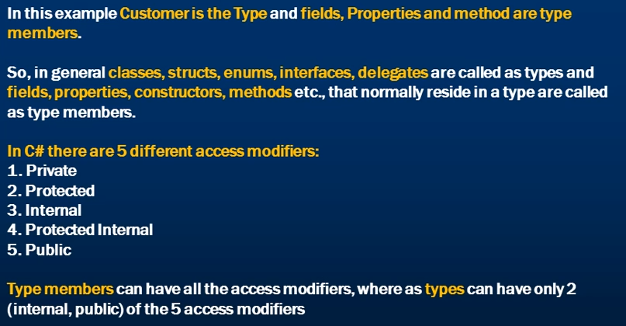

You can also make a class as protected but not the top level class.

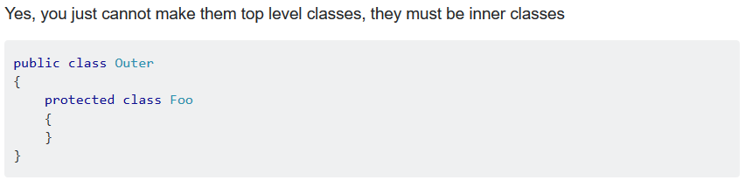

The inner class though is a type in C# but act as a type member for the outer class and hence can be marked anything of the 5 access modifiers.

# Access modifiers

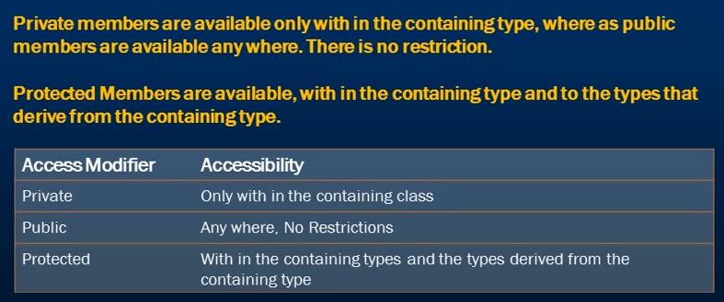

A derived class can access all the members of the base class that are marked protected or public.

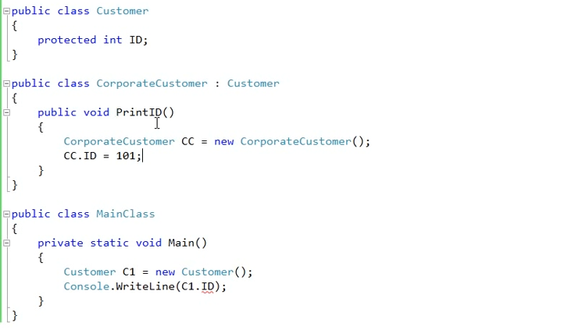

Base keyword in the derived class refers to the base class. So by using the base.ID we can access the ID field in the CorporateCustomer class. You can also use the this keyword.

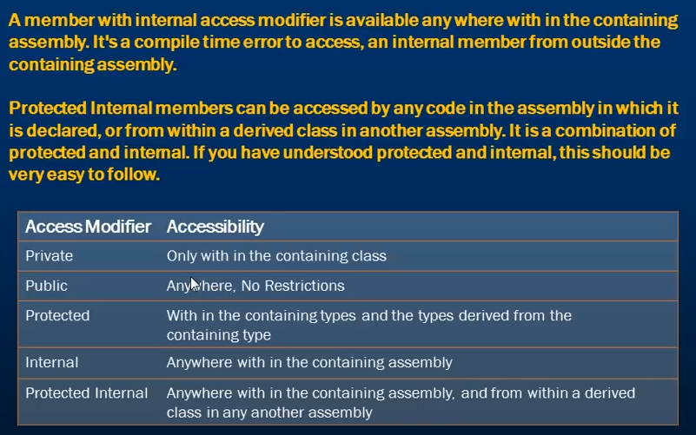

In .net, if you compile a project an assembly is generated. In .Net, assemblies are of 2 types. Executables and DLLs.

A console application, windows application generates an exe where as a web application, a class library generates a .dll.

The assembly contains intermediate language of your project source code. So all classes, methods etc will be compiled, intermediate language is generated and packaged into this assembly.

To understand internal access modifier, we need to have different assemblies.

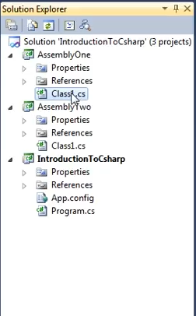

The project AssemblyOne and AssemblyTwo are class library projects so for each of these a dll will be generated.

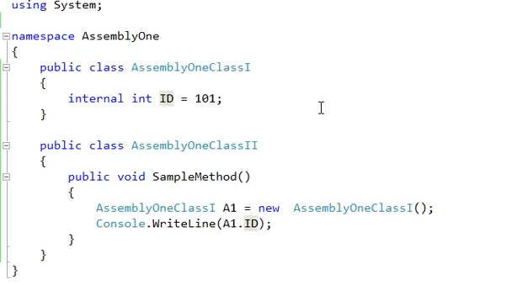

Here we are accessing an internal member of the AssemblyOneClassI in class AssemblyOneClassII.

Now let’s try and access the internal member of class AssemblyOneClassI in AssemblyTwo Project. It should not be accessible as internal members can only be accessed within the containing assembly.

So, let’s first add a reference of AssemblyOne project in the references of AssemblyTwo project.

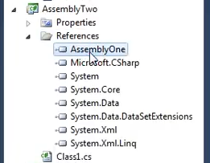

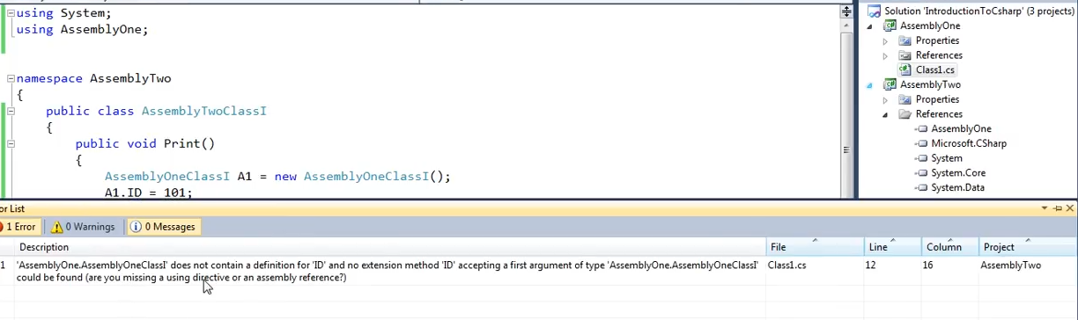

We get a compile time error as the ID is marked internal in the AssemblyOne class and so it is not accessible.

Protected internal is actually a combination of protected and internal.

So, protected internal is obviously accessible within the assembly but these members are also accessible outside the assembly in class that inherits from the containing class.

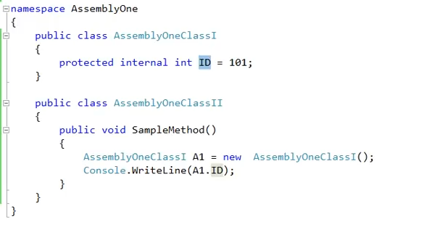

Now the ID field should be accessible in AssemblyTwo project if our class AssemblyTwoClassI inherits from AssemblyOneClassI.

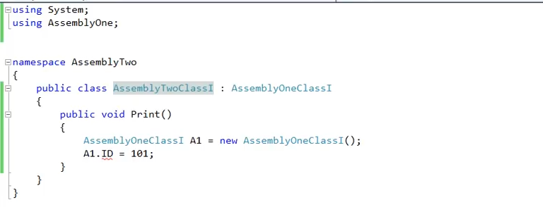

But, we see that it is not accessible due to the red mark below the ID. This is because it cannot be accessed through an instance of AssemblyOneClassI instance.

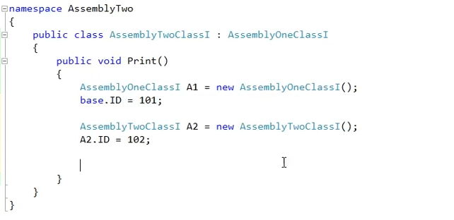

You can either access by using the base keyword or by having an instance of the derived class.

# Access Modifiers for Types

Elements defined in a namespace cannot be explicitly declared as private, protected and protected internal.

Elements like class, structures, interface, delegates etc because these are types.

Remember : For types, if no access modifier is provided, the default is internal. For type member, if no access modifier is provided, the default is private.

# Attributes

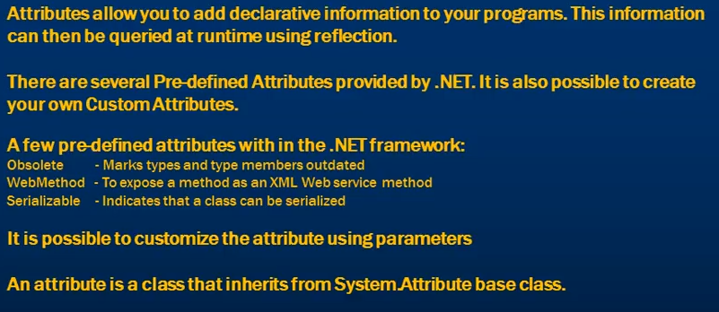

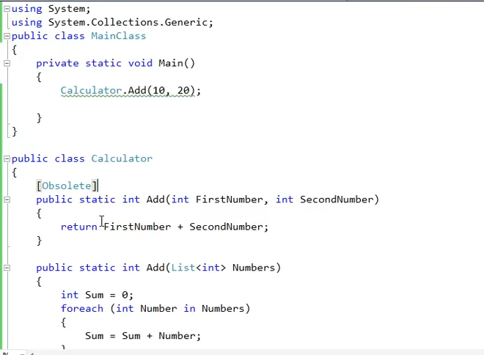

Sometimes we cannot delete a method previously written just for backward compatibility. In those cases, if we want the users to know and implement the new method instead, we can mark that method with an Obsolete attribute. now using the obsolete marked method is a compile time error.

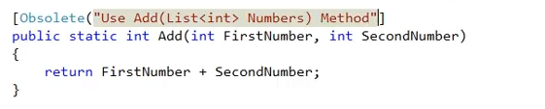

We can also add a message to say which method to be used instead of the obsolete ones.

By default, the usage of obsolete method is a warning in C#. if you want it to be an error, then you can also pass true parameter along with the message as above.

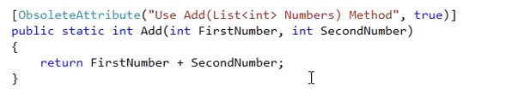

# Reflection

It is the ability of inspecting an assemblies’ metadata at runtime. It is used to find all the types in an assembly and/or dynamically invoke methods in an assembly.

Uses of reflection:

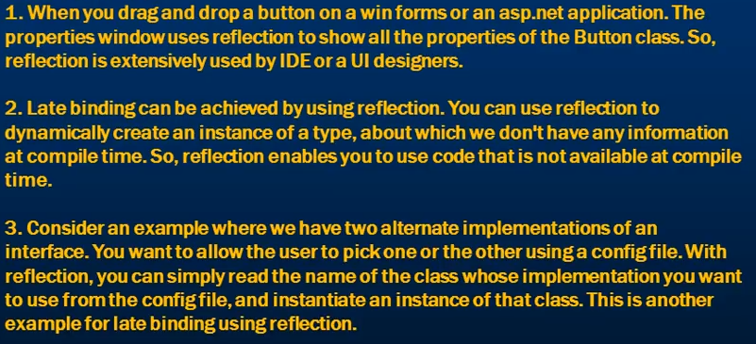

An assembly consists of two parts. First is the intermediate language and the second one is metadata. Metadata contains the information about the types in the assembly.

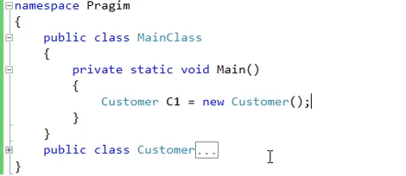

This is called as early binding where we are creating an instance of the customer class at the compile time.

Now suppose I want to write a method, which can list all the properties, methods, constructors etc of the customer class.

This is where we use reflection.

Reflection has got a specific class System.Type class. Most of the stuff that we can do with reflection is centered around this System.Type class. This class has a GetType() method which can be used to get the type of anything at runtime. This method takes in a string parameter which should be the name of the type. The name should also be the fully qualified name.

Say we want to get the type of the customer class. Then we need to pass in this as Pragim.Customer as this class is present in the Pragim namespace.

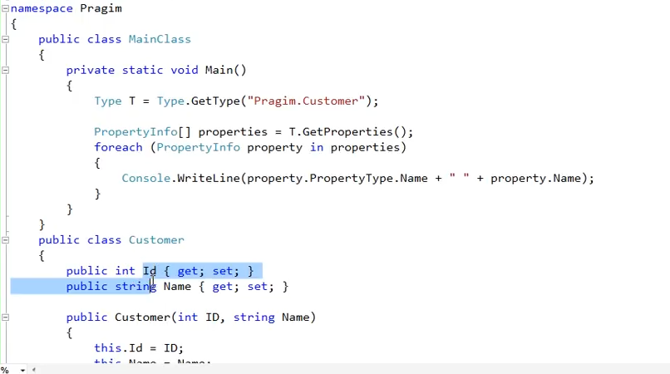

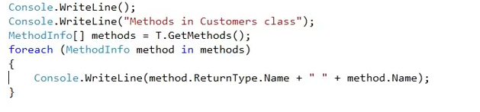

These are the methods that we get as output. Now we have only 2 methods in our customer class and those are PrintID(), PrintName(). The get and set methods are coning because of the id and name properties. Dotnet internally implements the get and set as getter and setter methods.

The 4 other methods like ToString, Equals, GetHashCode and Type are coming from the Object class. Everything in C# inherits from the System.Object class.

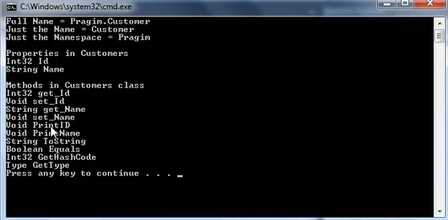

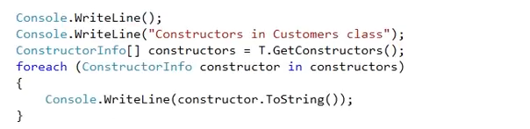

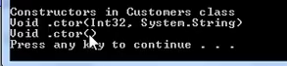

If you do not use the .TOString() then the parameter info of the constructor will not be available.

For fields use T.GetFields()

Use the method.GetParameters will give you the information on the method parameters.

There are several ways to get the type of the element inside an assembly. Uptil now we were using the static GetType instance of the Type class.

We can also use the typeof keyword.



With the typeof keyword you actually have to pass the class name.

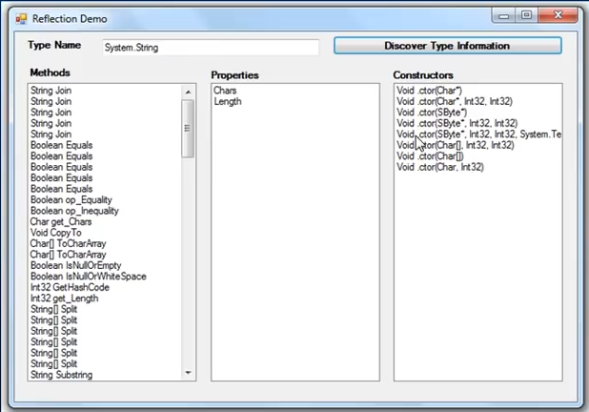

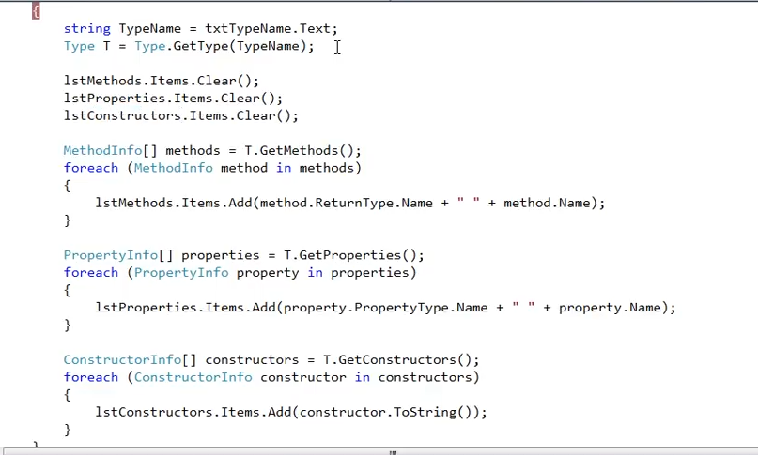

# Late binding using Reflection

First of all you will have to load the assembly which contains your class.



This loads the currently executing assembly.

Now within this assembly we have two classes. MainClass and the Customer class. Now we need to load the customer class dynamically at runtime.



Now we want to get the method that we want to execute but before that we need to create an instance of our dynamically created customer class. To instantiate the class



Now we need to get the method information for it to execute. Method information is available with the customer type.



Now this method takes in 2 string parameters as firstname and lastname so we need to create these two parameters.

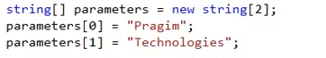

Finally, we need to invoke the method. In early binding, we use instance.methodName to invoke the method but here we cannot do that. This is because the instance we created is of type object as we do not have the customer class. And since it is not as the type of customer we cannot use customer.method to invoke the method.

To execute/invoke the method we need the instance of the class and the parameter list.



Finally, we write the output to console.



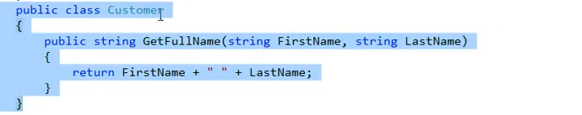

# Generics

It allows us to design classes and methods decoupled from data types.

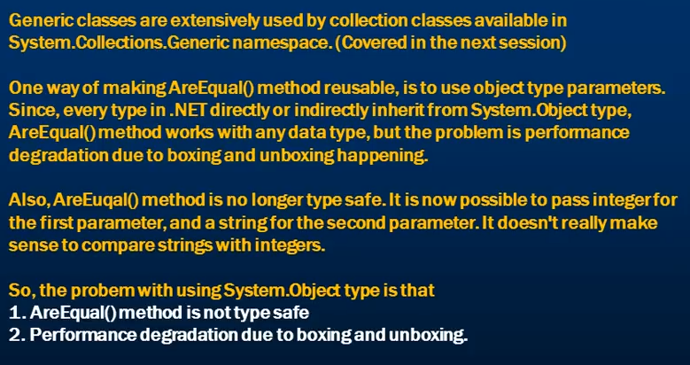

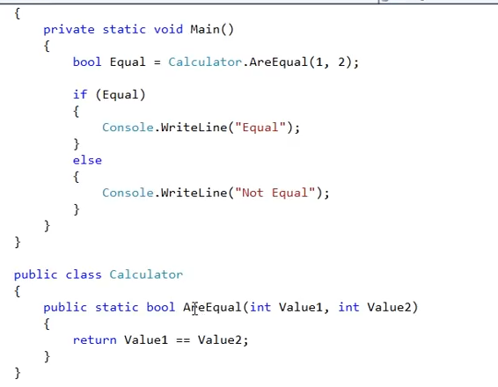

We are calling our are equal method to see if the passed integer values are equal or not. Here the are equal method id tied to the datatype.

To make this are equal method to be used with any data type, we can make the parmameter datatype as object since everything n C# inherits from object. But now someone can pass the first parameter as integer and the second as string. And it will make no sense for our method to compare int with string.

To solve these problems we can use generics.

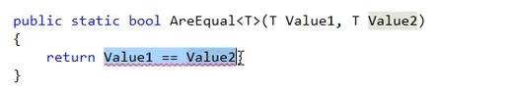

We put an angle bracket after the function name which indicates that it is of some type that we don’t know and will be determined at runtime. Both the parameters are now of the type T too.

Since the parameters are of the type T, we cannot compare them using ==. We need to use the .Equals method

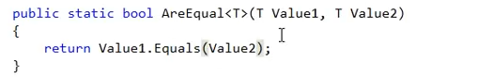

This is ow we can call our function and use it now.



Similar to this, we can also make class generic.

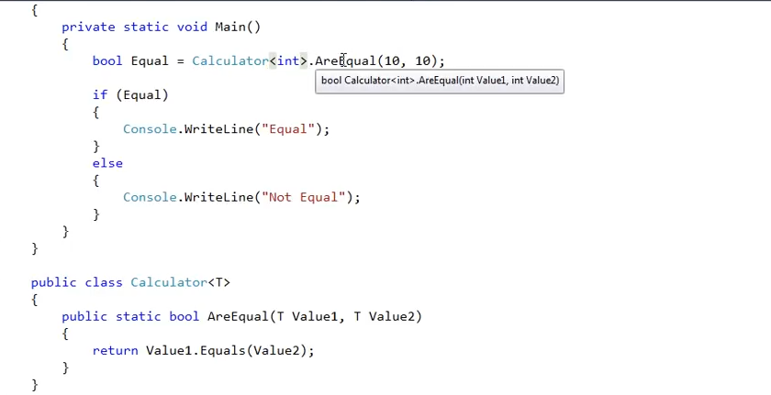

We are saying now that we want the class Calculator to operate on integers.

# Why should we Override ToString() method

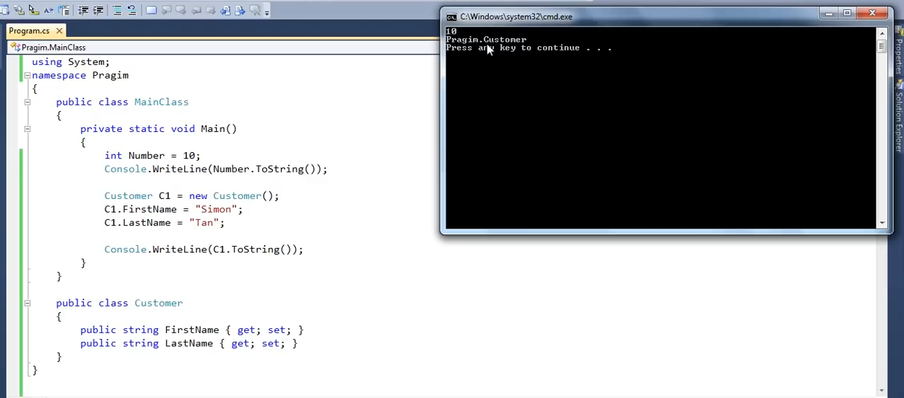

Notice that the integer value of 10 is successfully represented as string but with complex types like class, when we print the ToString() value of the class object, it prints the fully qualified name of the class. But now suppose that we want something else to be printed when we call ToString() on object. To do that we can override this method.

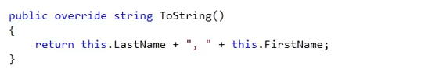

# Override Equals method

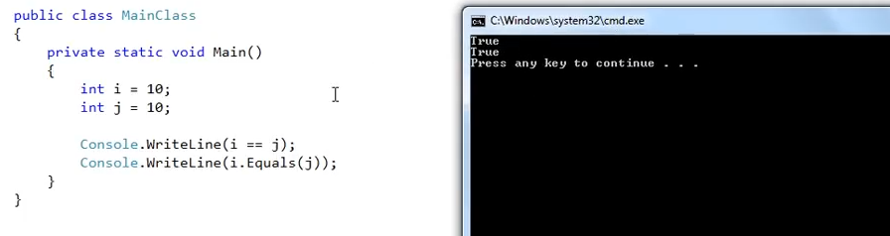

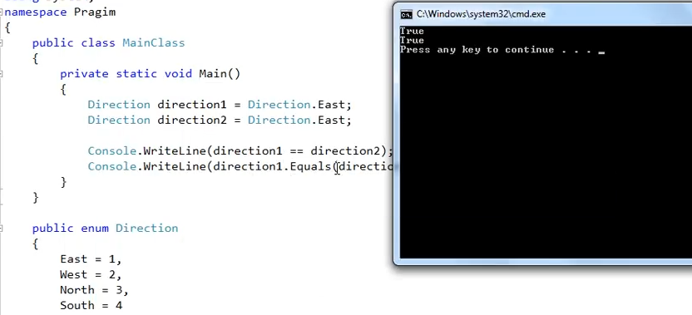

Since Enums are also value types, both == and Equals works fine. But when it comes to reference types

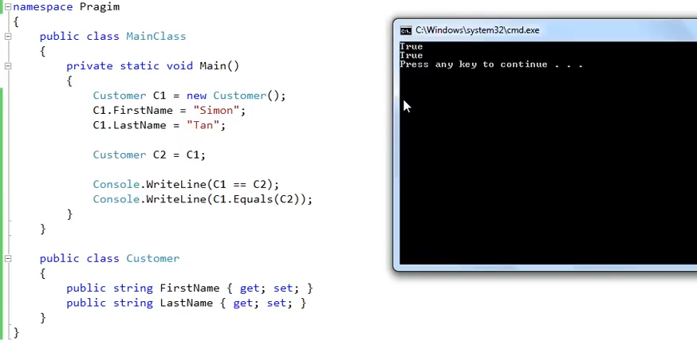

Although we have different values in FirstName and LastName we see that the Equals and == say that both are equal. This is because these reference variable C1 and C2 are pointing to the same object.

Since we have made C2 = C1 both the reference variable now point to the same object on the heap. So the data they have in them are also equal and any change in one object will be reflected in the other. Meaning, if we change the value of the C1.FirstName, it will be reflected in C2.FirstName.

In case of objects, == is used for comparing the referencing equality which will be true in the above example as both the objects were pointing to the same object.

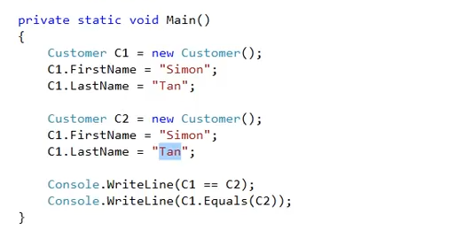

Now we have 2 different customer objects. So the == will be false as there is no reference equality. Both the objects now point to the different objects.

NOTE: == is used for reference equality and Equals is used for value equality .

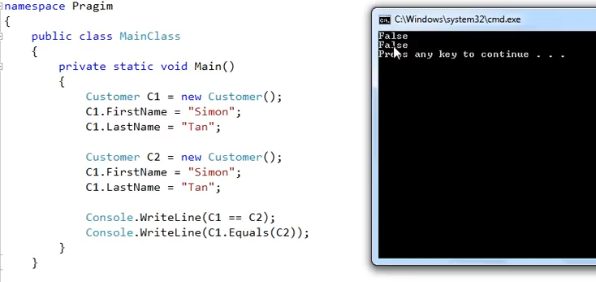

We see that the values in both the objects are equal even they point to different object. == gives false is understandable as the references are different but .Equals giving false. So this is the reason, we need to override the .Equals method.

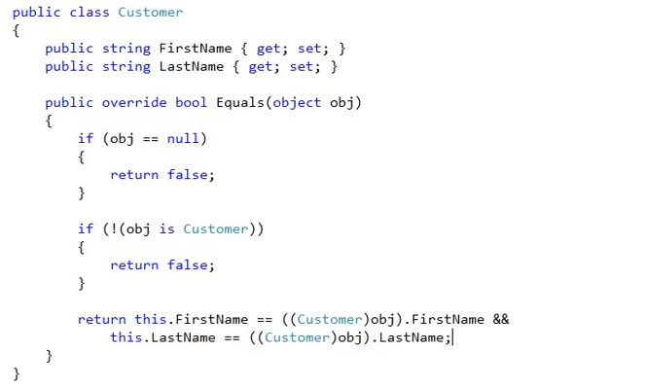

It is recommended to override GetHashCode() also if you are overriding Equals method other wise the hashcode not gurantee to be unique.

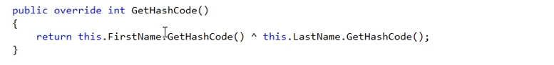

# Convert.ToString v/s ToString()

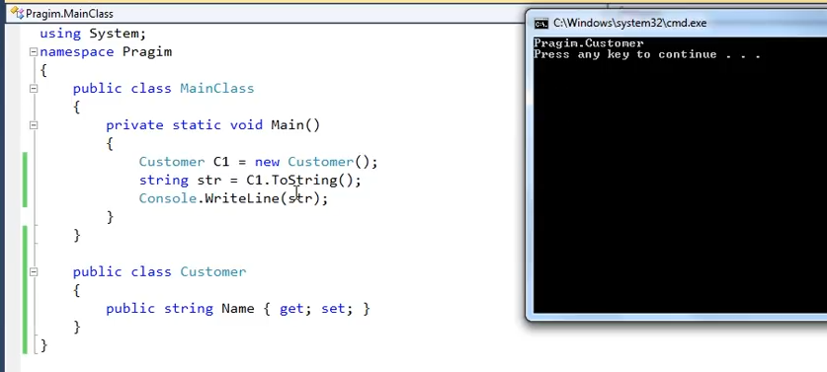

We get the fully qualified name as the output

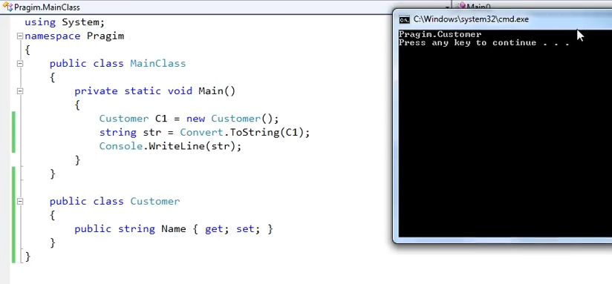

The same output again. There is no difference with the convert.ToString() as well.

The difference is with the null case.

If the class object is null then convert.tostring() converts that null into an empty string.

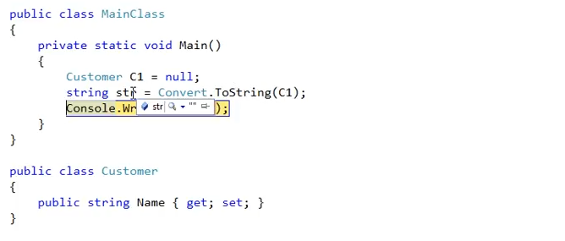

But when we use the ToString() method on the object, we get a null reference exception.

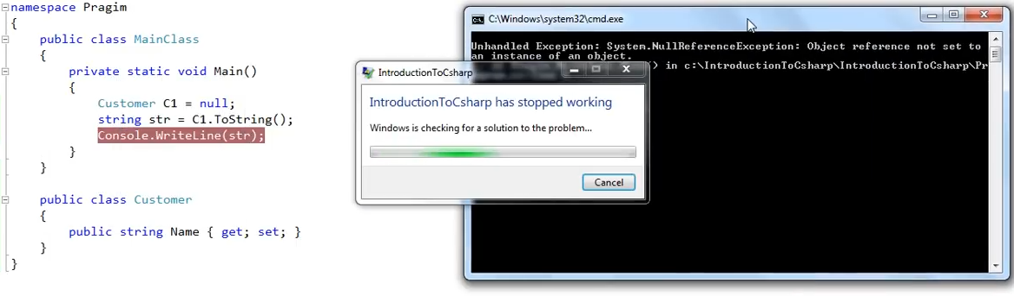

The convert.ToString() is a static method on the Convert class but the toString() is an instance method. When we try to call ToString() instance method on a null object, we get a null reference exception.

# String v/s StringBuilder

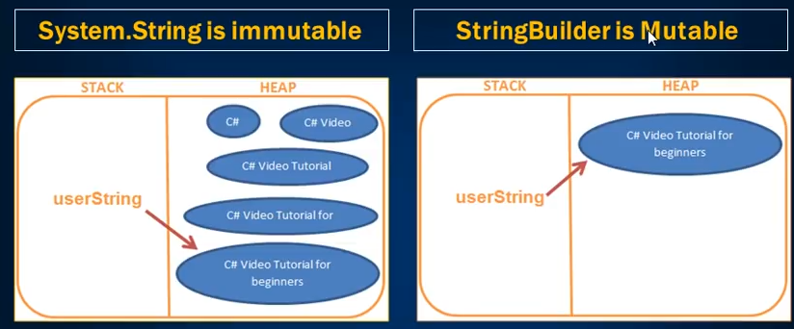

Use StirngBuilder when there is a heavy string manipulation is involved.

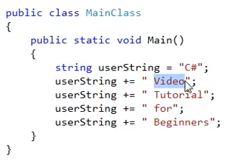

We have a userString here and we are concatenating it 5 times to print “C# Video Tutorial for Beginners”. Basically we are changing the same string object 5 times.

At first, the reference variable userString in the stack will be pointing to the “C#” object on the heap and we wouldn’t have the other objects as shown in the picture. Then when we concatenate the “Video” keyword to the variable, it creates another object with “C# Video” on the heap and now the reference variable points to the new object.

This is what it means by immutable. Meaning you cannot change the same object in the memory when you concatenate a string variable. The memory for all the other 4 objects on the heap will still be present and the variable will point to the final object on the heap.

The other objects will be cleaned by the garbage collector.

Strings of type StringBuilder is mutuable meaning that the same object on the heap can be changed over and over again. This way we only have 1 object on the heap. This is why StringBuilder offer better performance than string objects when heavy string manipulation is involved.

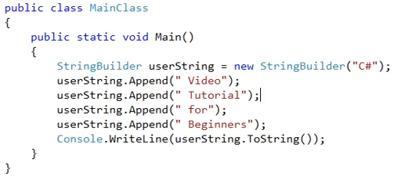

Now this code is more efficient.

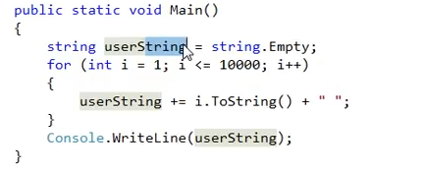

In this example, 10001 objects will be created on the heap and we will be using only one. Rest of the 10000 objects will take memory and will wait for the garbage collector to clean them up.

# Partial Classes

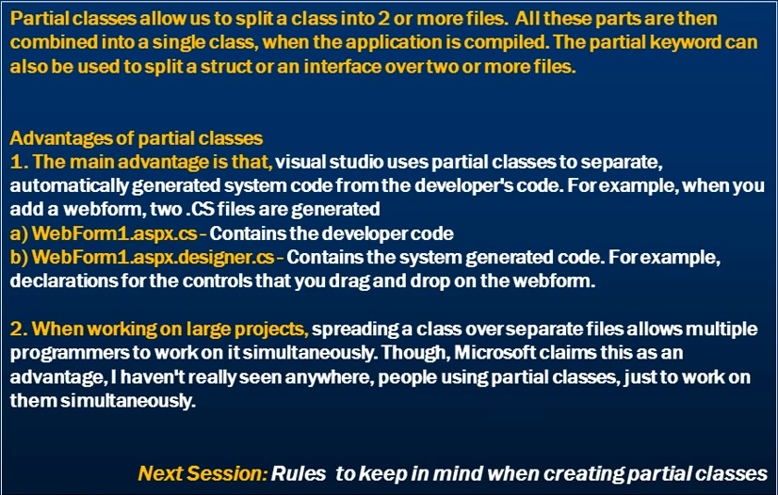

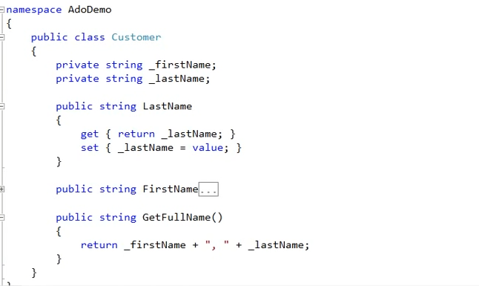

Now let’s split this into 2 files. Let’s add two .cs files with name “PartialClassOne” and “PartialClassTwo”. We will name the class as PartialCustomer.

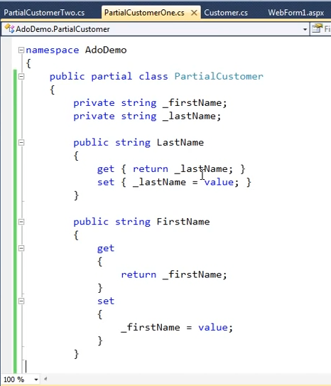

This partial class contains the private fields and public methods to initialize them.

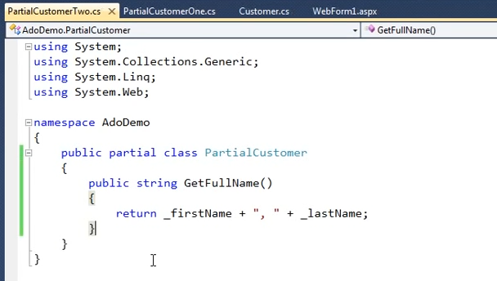

This partial class two contains the rest of the public methods.

Notice that the _firstName and _lastName are not defined anywhere within the second partial class. But the build still succeeds. Because of the partial keyword used in the class, the C# compiler knows that this is a part of the class. These fields might be present in the other partial class parts.

When we compile the project, the two partial classes are combined as one class.

We use the partial classes the same way we use the normal classes.

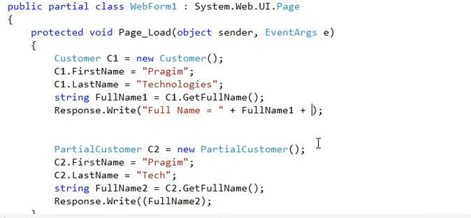

# Rules to follow when creating partial classes

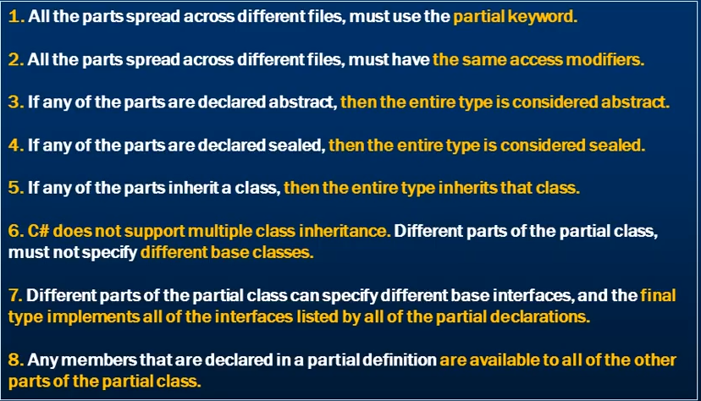

# Partial Methods and Rules to follow for partial methods

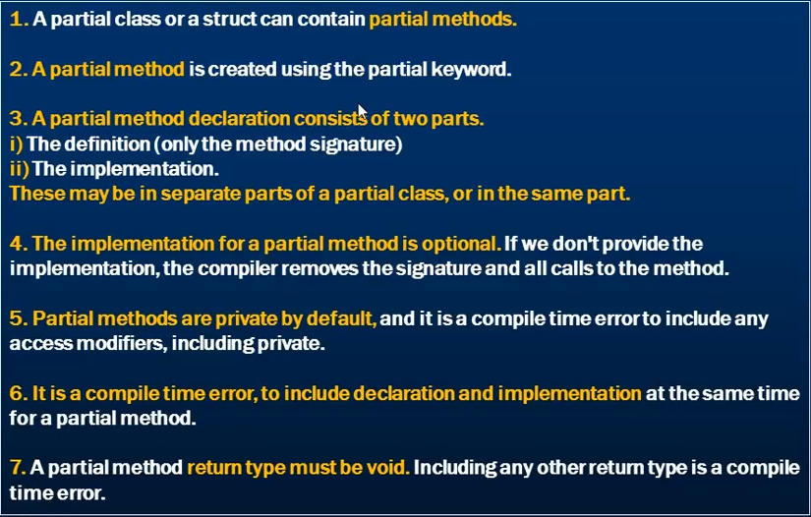

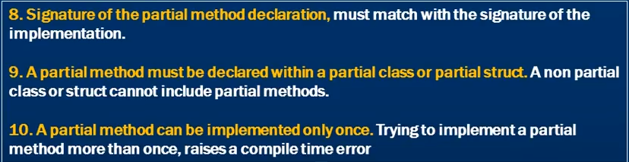

# How and Where are indexers used in .NET

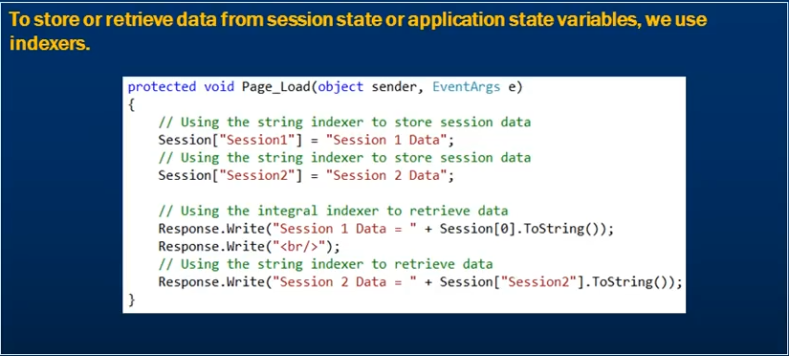

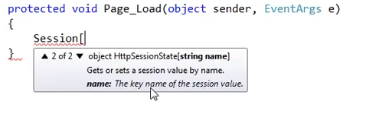

We can see that we have 2 indexer defined for the Session to store session variables. Note the Big Bracket here. We have seen the same thing for overloaded methods where the intellisense shows something similar to this. But in case of methods the we use small braces.

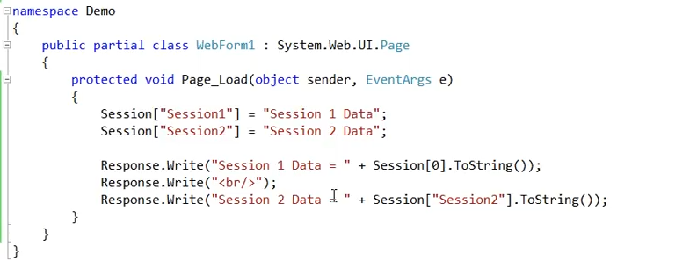

To get the data from the Session1 we are using the integral indexer. To get the data from the 2nd, we are using the string indexer.

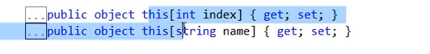

This is how we create indexer. We use the this keyword and then in curly braces the type of data it can get as the key.

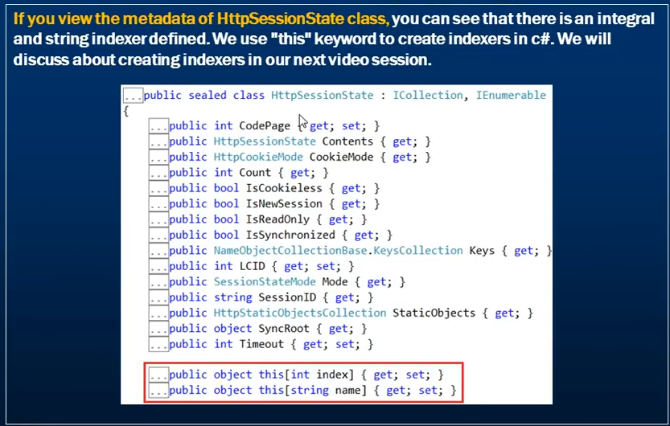

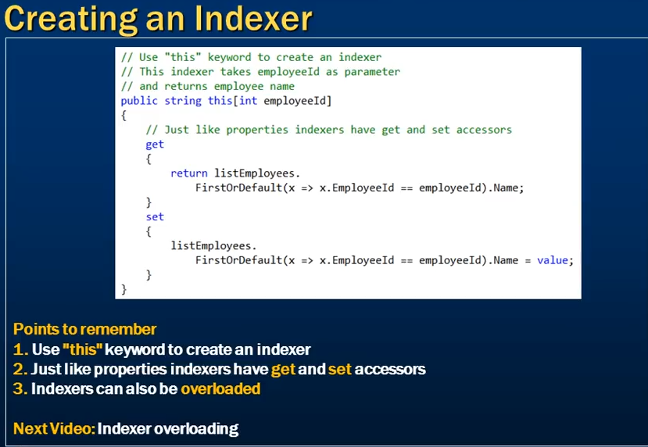

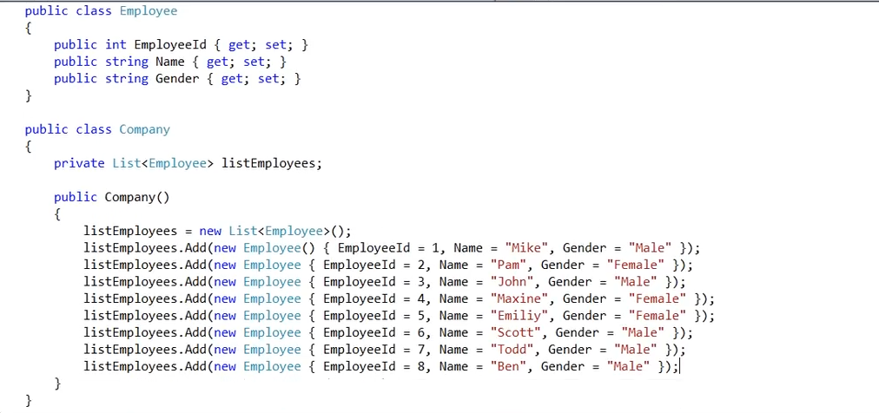

Now we want to use the Company class and retrive the employee using the employeeId. And at the same time using the employeeId indexer, I should be able to use it to change the employee name as well.

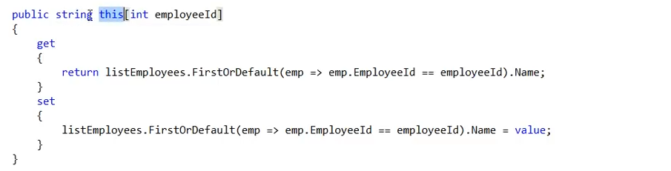

This is created in the company class. Now let’s try to use this.

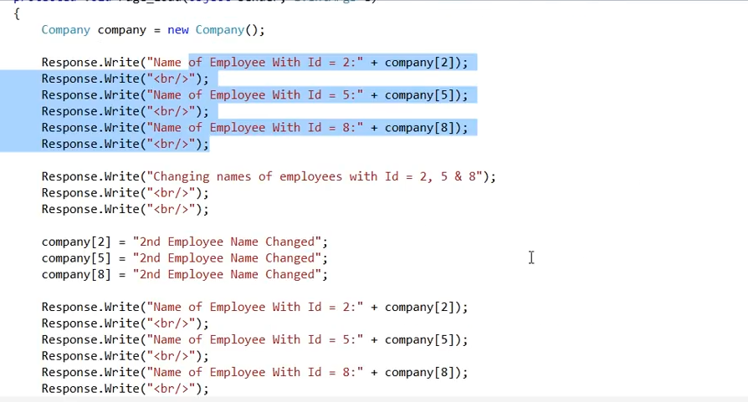

Overloading indexer.

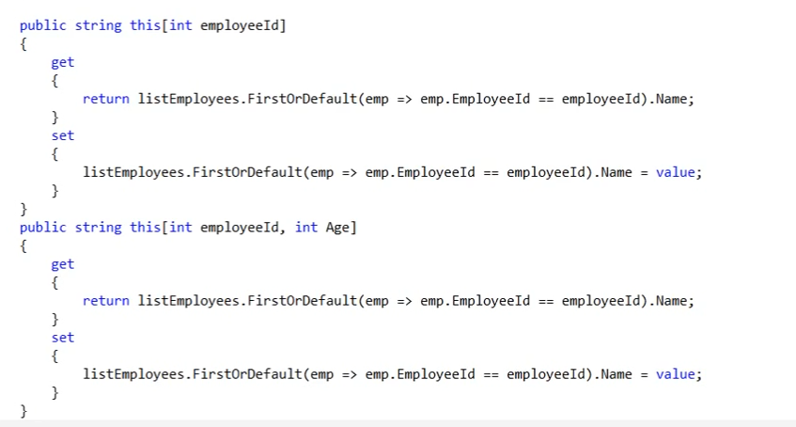similar to method overloading.

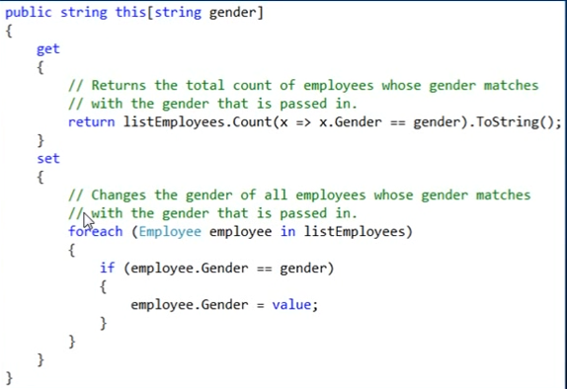

# Optional Parameters

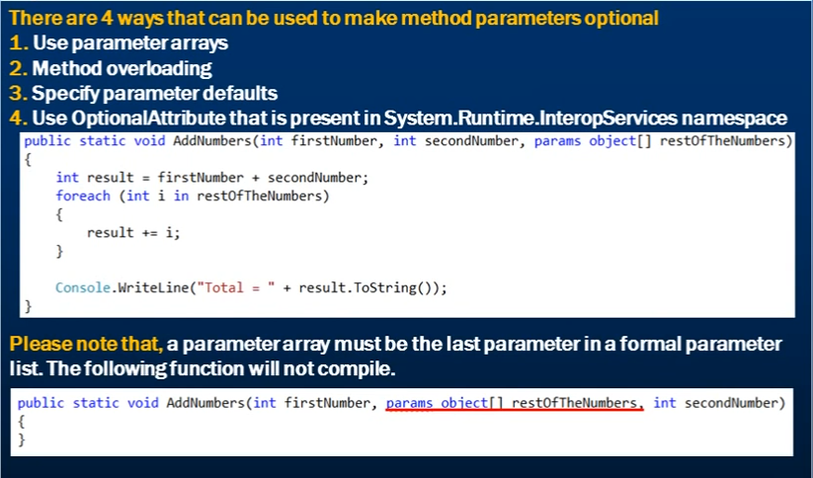

## Using the params keyword

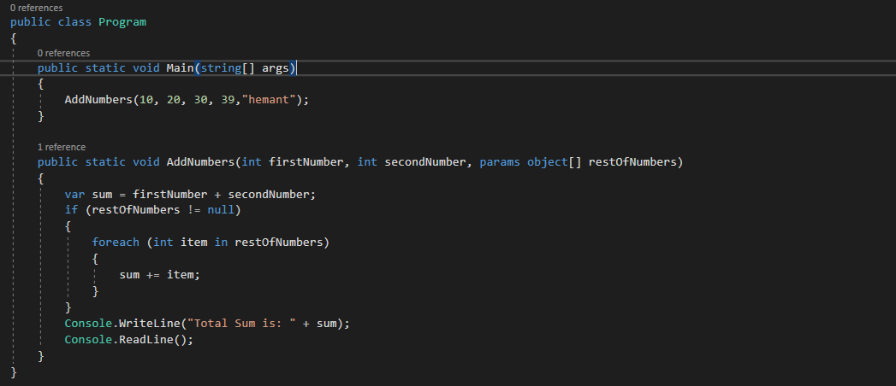

Notice that the params argument type is an object array and that is why it is not showing any compile time error for the passed in value of “hemant”. But when we run this, it will break as it will unable to parse “Hemant” value to int in the foreach loop.

The solution to this is to use the int array as the parameter type for the params argument.

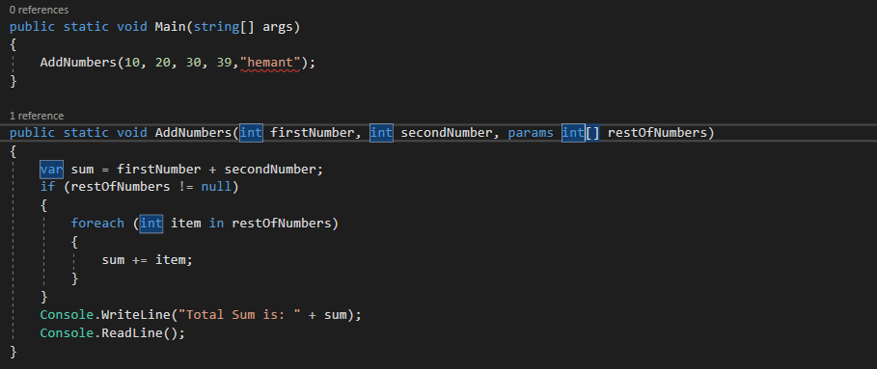

This way we will get a compile time error.

## Using the method overloading for making optional parameters.

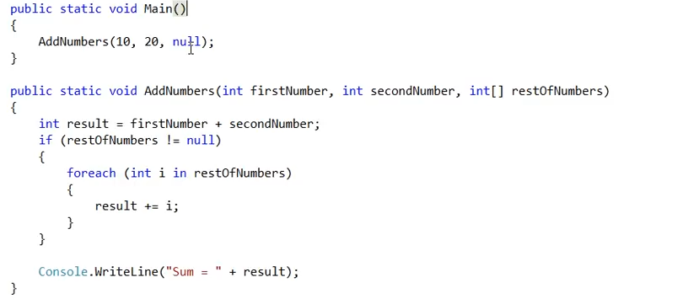

Here the 3rd parameter is not optional. We have to pass null.

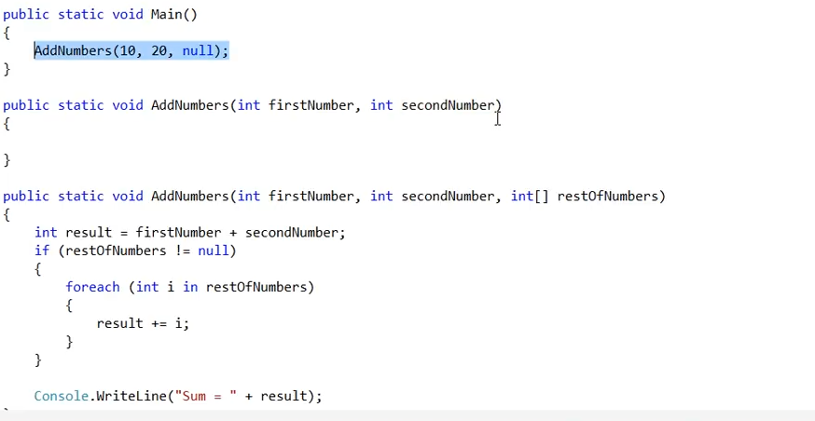

Now the 3rd parameter is optional because of the method overloading.

## Optional parameters by specifying parameter defaults.

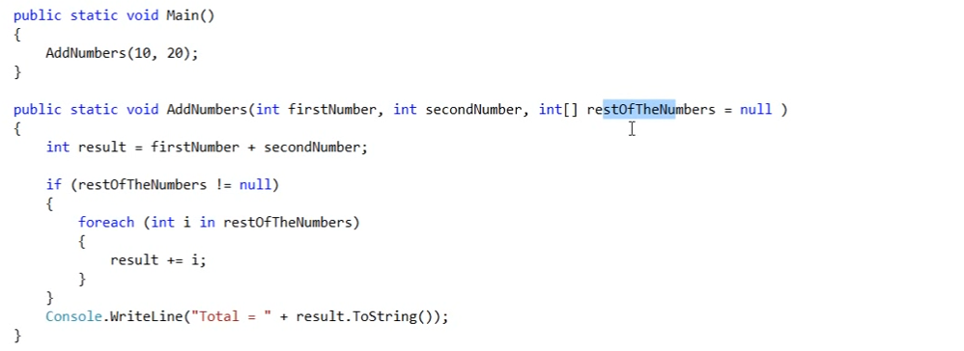

This way if we don’t specify the 3rd parameter, it will by default consider its value to be null.

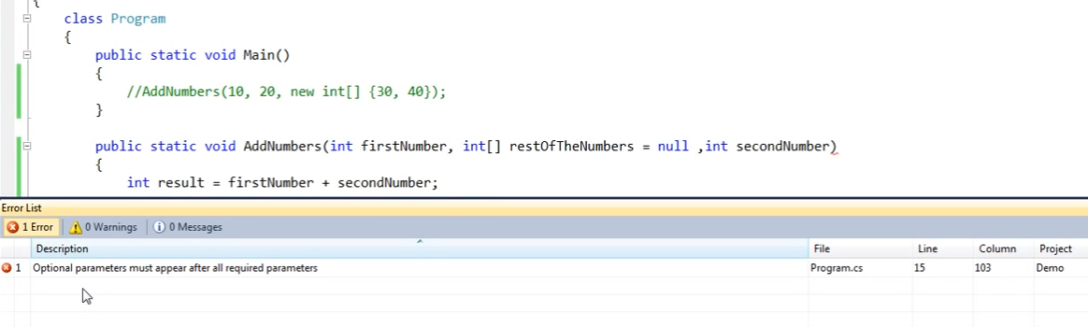

Remember that the optional parameters are always to appear at the end.

### Named Parameters

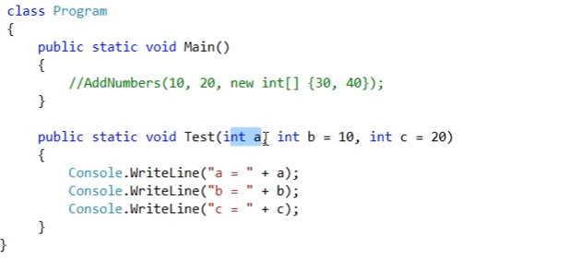

Notice that the Test method has 3 parameters out of which only a is mandatory.

Now let’s say that we want to pass the value of a as 1 and the value of c as 100 without specifying the b parameter. This can be achieved by using the named parameter.

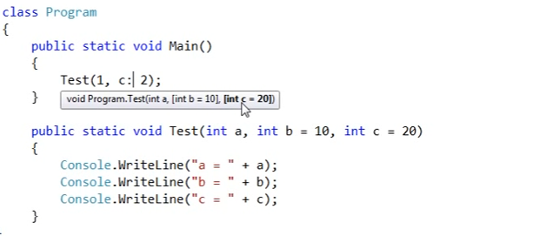

Doing so is also shown in the intellisense that the value will be assigned to c parameter of the Test method.

# Parameters optional by using the OptionalAttribute

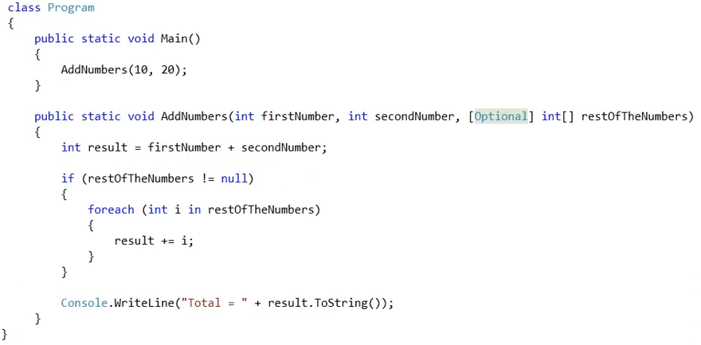

# Code Snippets

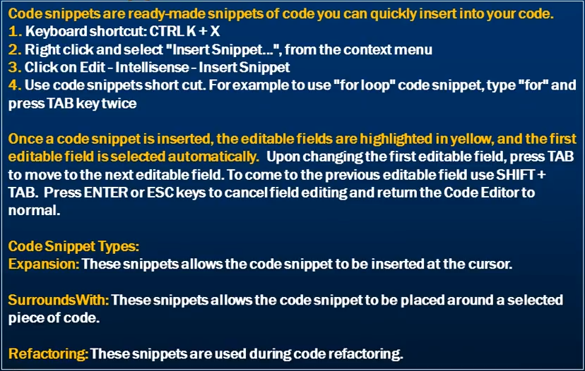

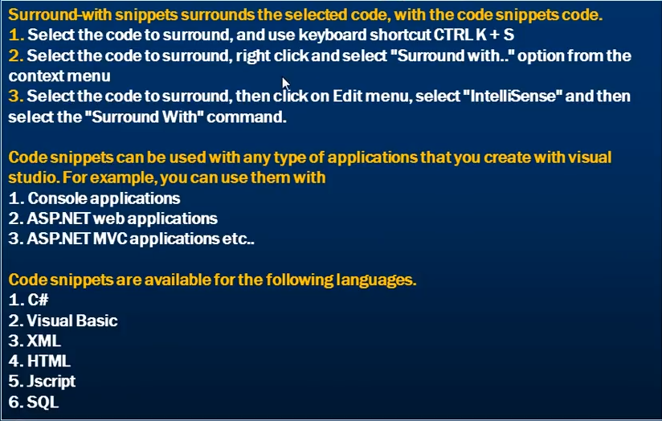

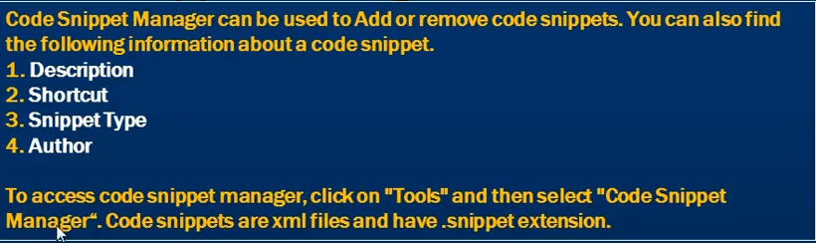

# Dictionary

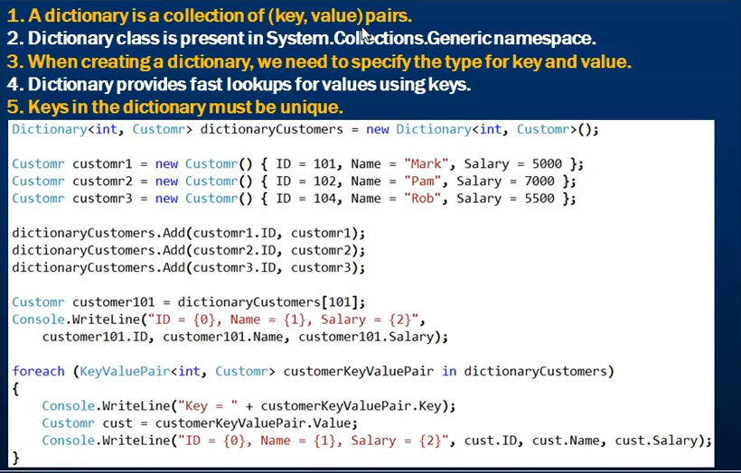

TryGetValue() -> use this function when you are not sure if the dictionary contain a specific key. It returns the value associated with the key passed to it.

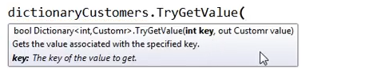

The out parameter is passed uninitialized. If the key is not found the default value of the out parameter passed is returned.

The function returns a bool value of true if the key is found and false if the key is not found.

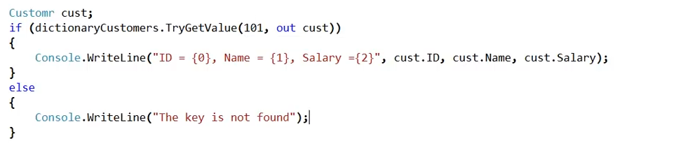

In the above example, if the key is not found the cust object is null. We don’t get an exception even if the key is not found.

Using Count() function on dictionary.



Using the Remove() function

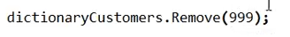

If the key is not present in the dictionary, then no exception is thrown and nothing happens.

Converting an array into dictionary. On doing this, we need to specify what is going to be the key and what is going to be the value.

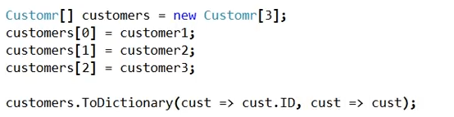

In the above example, the key is going to be the customer id and the value is going to be the customer object.

Converting a list into dictionary.

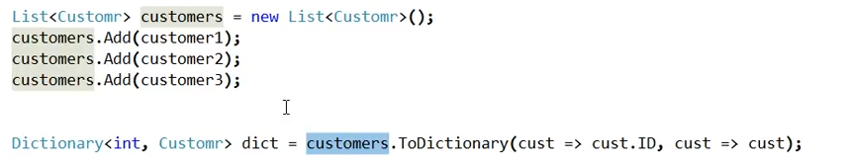

# List Collection Class

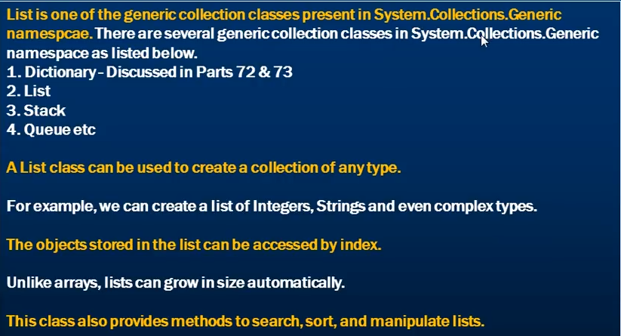

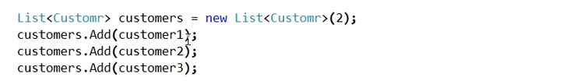

Even though we have set the capacity of the list to 2, we will not get any exception even after adding 3 items. This is because, lists grow in size automatically.

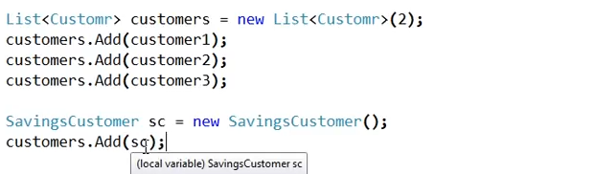

Here SavingsCustomer is a class that inherits from the Cstomer class. So we can also add an object of the derived class to the list of type of base class customer.

Adding an object at the fixed location in a list. We are going to add customer3 at the 0th index.

Function Add() on the list adds the object at the last of the list. We can use the Insert() function for this.



Doing so will shift the other object index.



This will return the index of the first match and that is the 0th index.

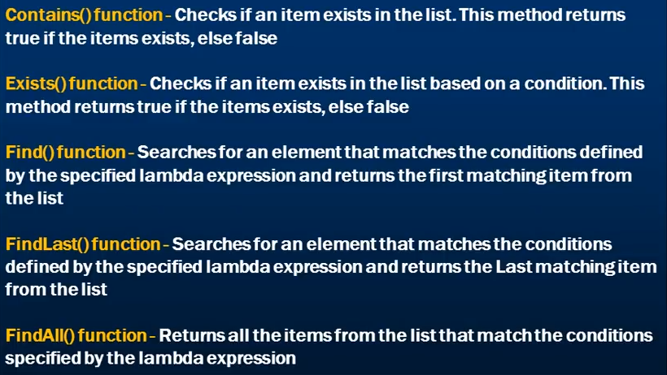

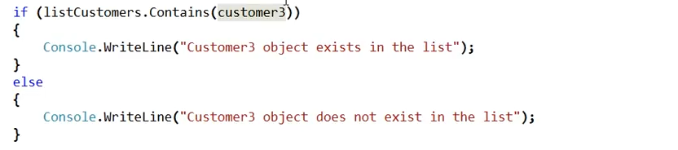

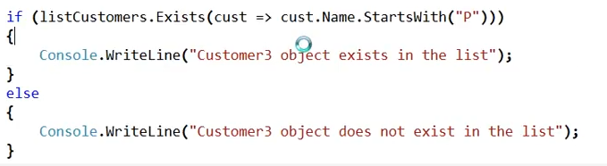

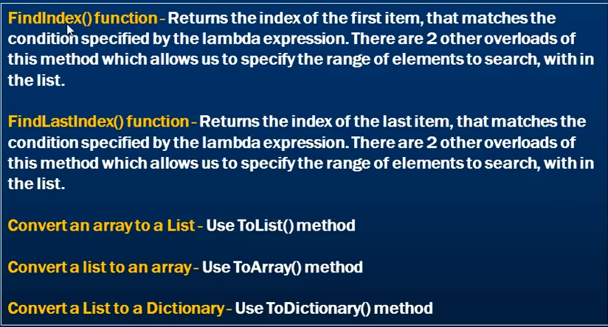



# Working with generic list class and ranges

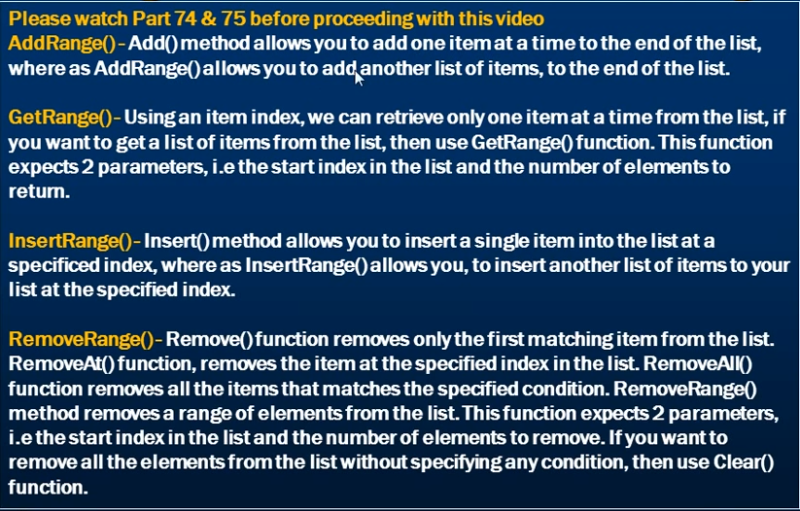

# Sort a list

Simple types include int, float, decimal, double, string, char etc.

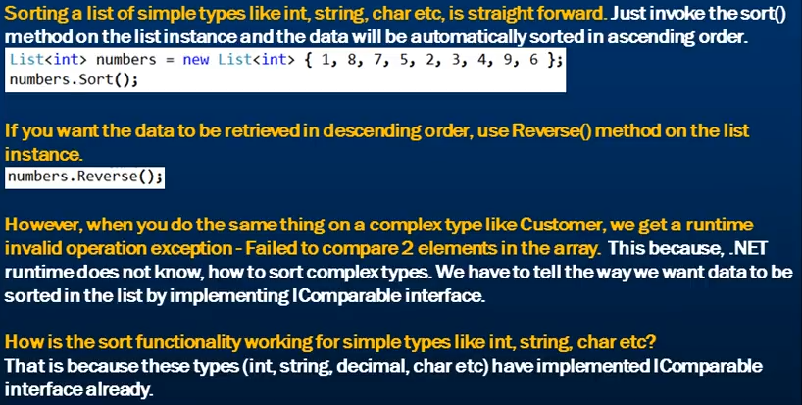

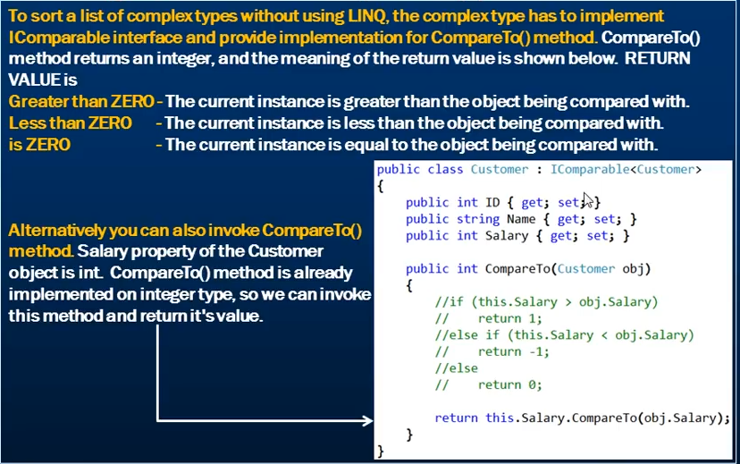

The commented code is the actual implementation that we need to implement. Since salary is of the type of int which has already implemented this CompareTo() method of the IComparable interface we can directly use that.

This is what the last line is about. We are using the already provided implementation of the int struct.

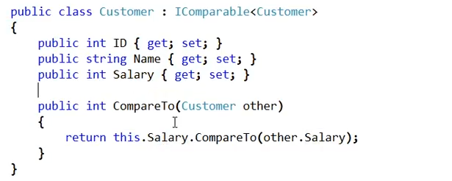

But now if we want to sort the customers on their name then the default implementation of sorting on salary is useless. This is where we use the IComparer interface

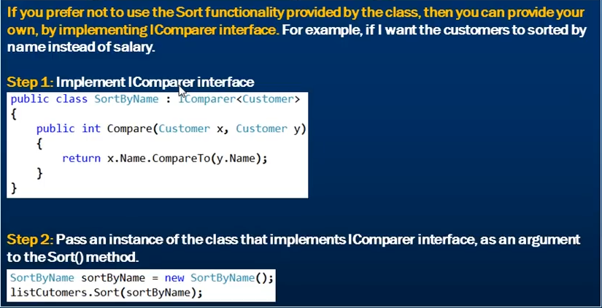

If instead of making a class and then implementing a IComparer interface seems a little overcoding then we can also use the IComparison interface to implement a delegate for sorting.

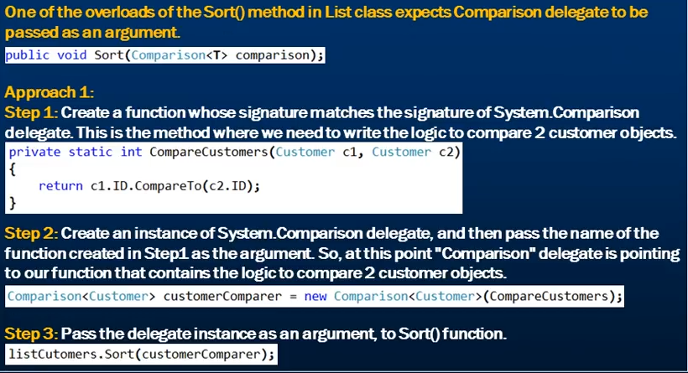



Pressing F12 on the Comparison we can see the below definition of the delegate.

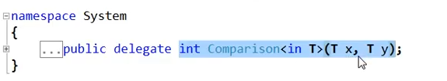

There’s a lot of code in the above approach

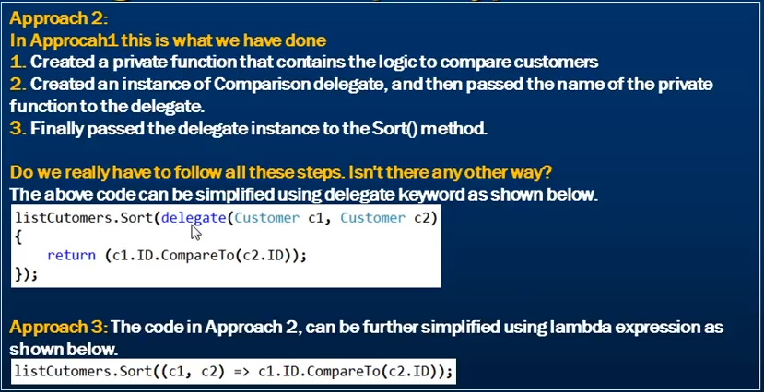

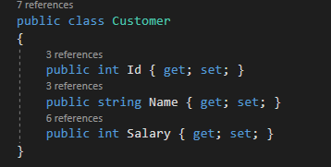

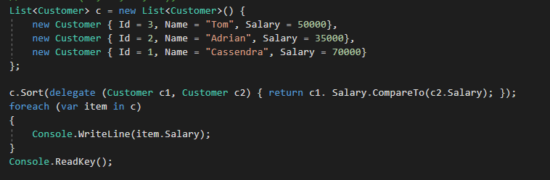

**That’s it.** We are done. It is very less code doing the same work for us. This can also be simplified using the lambda expression.



This is simpler and easier to understand now. The delegate pointing to a function needs two objects to compare which the c1 and c2 are representing and then simply compare.

# Some useful methods of list collection class

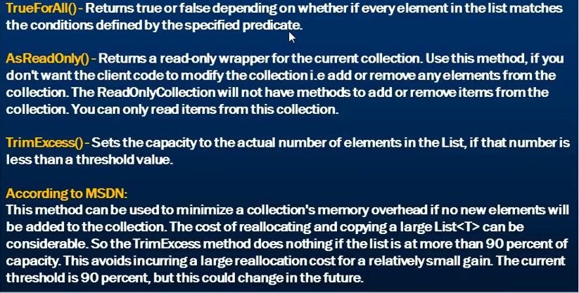



If we want to check that all the customers have salary more than 5000 or not. If all the objects in the list matches this condition then TrueFOrAll returns true else false.

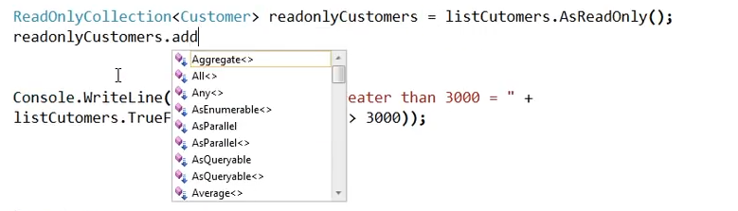

Notice that, after making the Customer list to readonly, we don’t have add method present anymore. AsReadOnly(0 method returns a ReadOnlyCollection which is present in System.Collection.ObjectModel namespace.

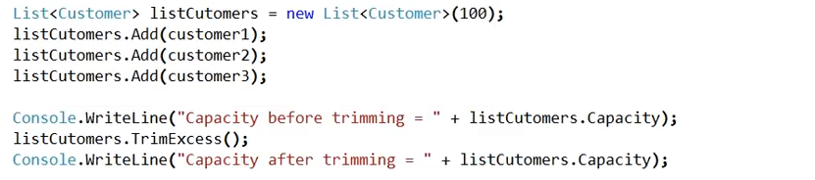

TrimExcess() will reset the original capacity from 100 to 3 in our case. It resets the capacity of the list to the number of elements present in the list if it is lower than a threshold value.

What this method does is reallocate the memory with the actual number of elements present. So in our example, it might benefit us as we have the capacity of 100 and have only 3 elements in the list. So reallocation of 3 elements will improve the performance of our application. But if we had a capacity of 100 and already have 90 elements in the list then calling TrimExcess() will not be of any benefit for us as the overhead of reallocating 90 elements will be high and will be much expensive then the performance we will achieve. This is why the threshold value as per the MSDN is 90 percent.

So, if the list capacity is full to 90 percent then invoking TrimExcess() method will do nothing.

# When to use a Dictionary

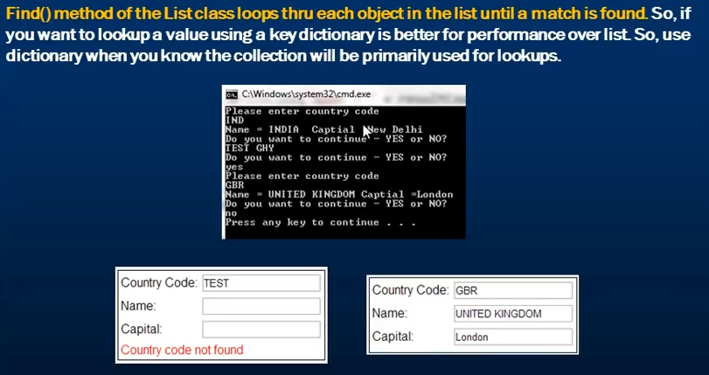

# Generic Queue Collection class

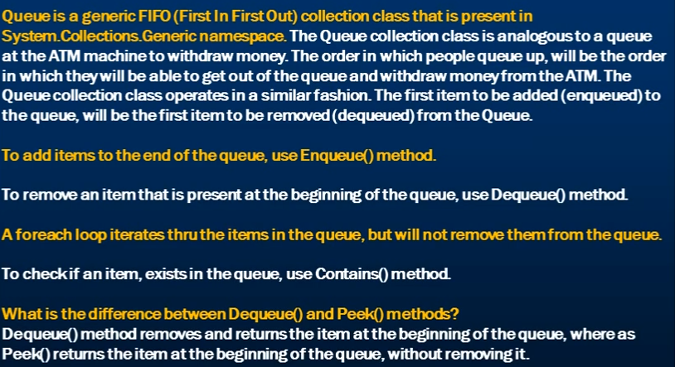

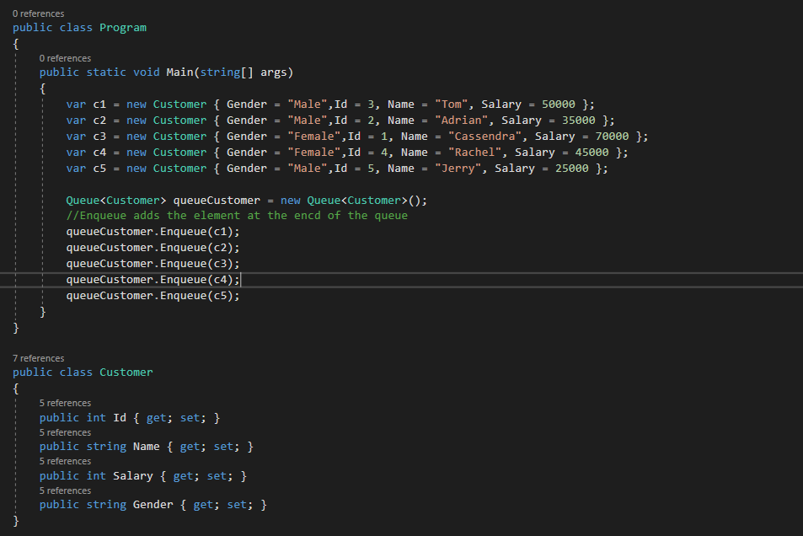

Dequeue is used for removing an element from the queue and it returns the element at the beginning of the element



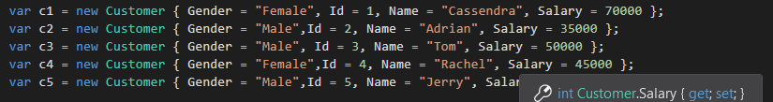

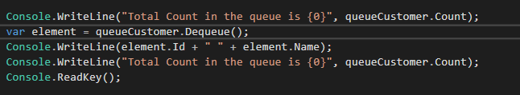

Now the dequeue will remove Cassendra from the queue and return that object.

Peek() method returns the first object from the queue without removing it.

# Generic Stack Collection class

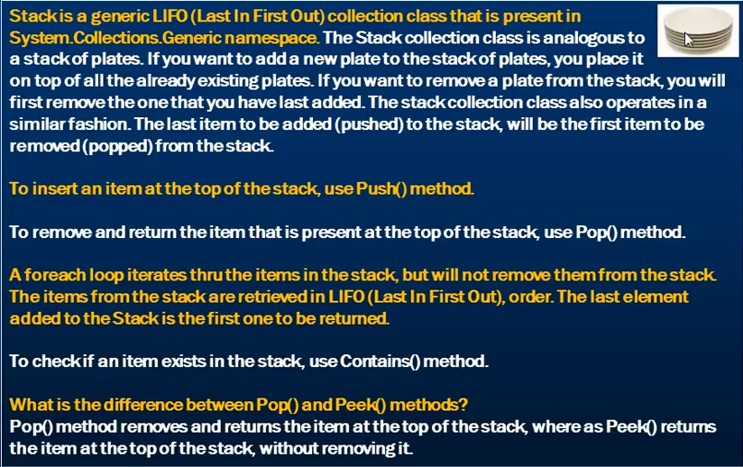

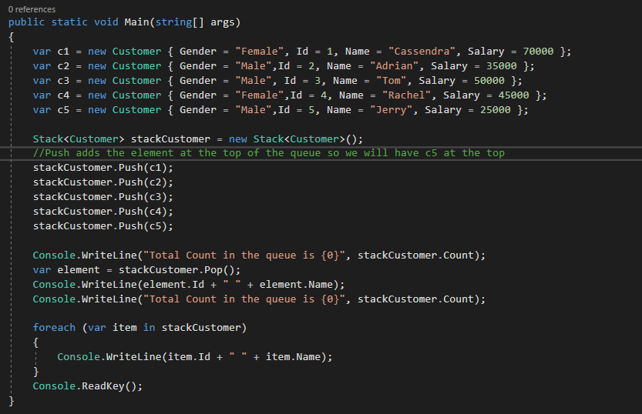

Pop will remove the last item that is c5 from the Stack.

We can use the Peek() method to see what element is at the top without removing it.

# Real Time example of a Queue collection class

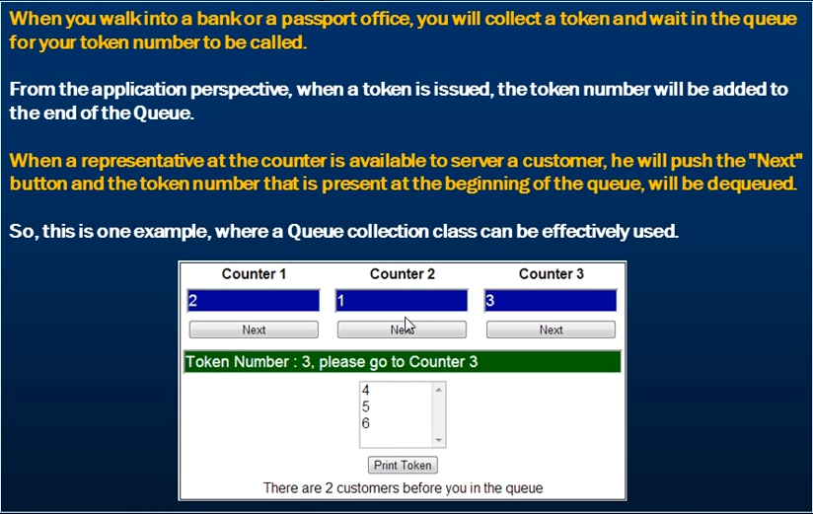

On clicking the Print Token, a new item will be Enqueued into the list and will be displayed in the queue list.

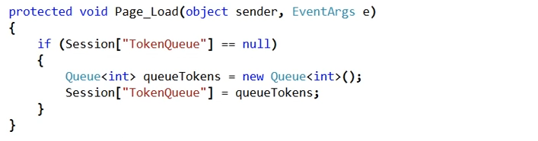

As the web application is stateless, we need to store the queue either in the database, xml file, session variable, application variable etc.

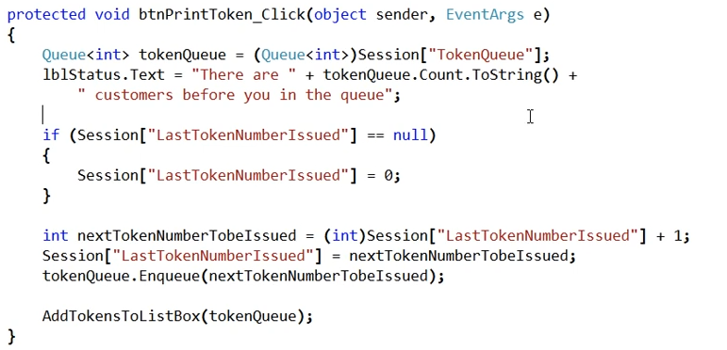

# Real Time Example of a Stack Collection Class

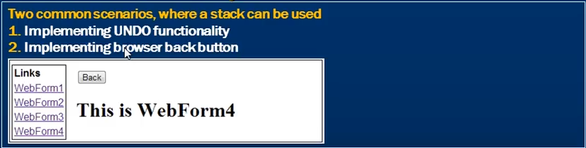

The design of the page is a master page.

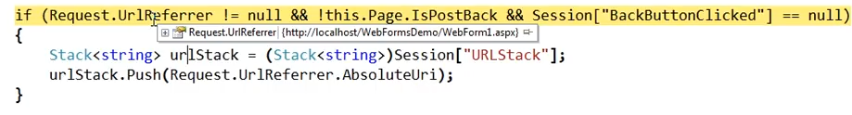

UrlRefrerrer is null if have landed on a page directly but contains the url of the page which has redirected you to the new url.

# Multithreading

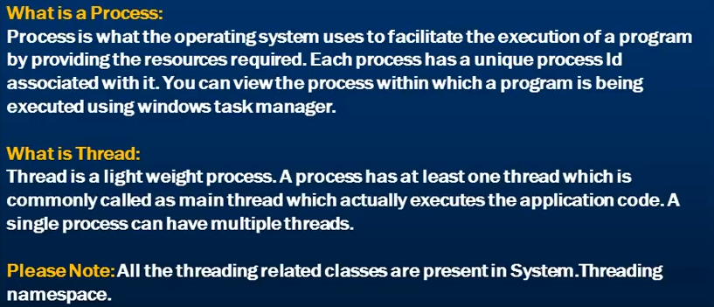

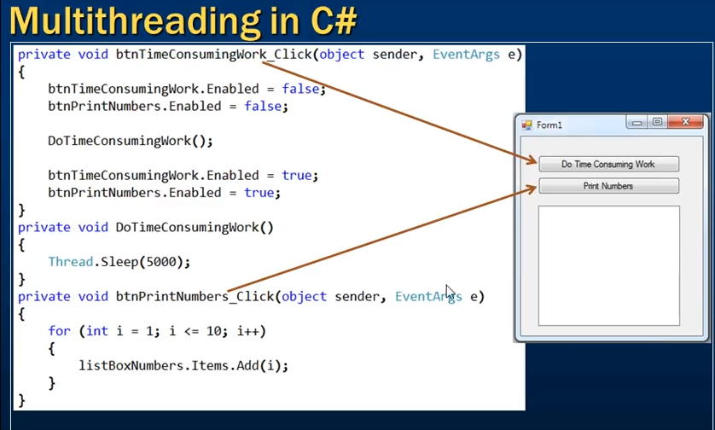

When we click on the button called “Do Time Consuming Work”, then even if the Print Numbers button is disabled, we will not be able to print numbers in the list box until he main thread executing the time consuming work is finished.

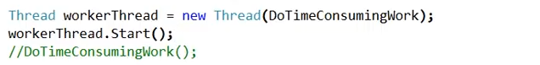

So, to make it work what we have done is commented the direct call to the “time consuming work” method. We are not going to call this method on the main thread. Instead, we will open a new thread and pass that thread our function. Now this new thread “workerThread” is responsible to executing te “time consuming work” and not the main thread.

The thread will only start execution after being called the Start() method on it.

By default, we get only one thread with a process that is responsible for executing the application code. This thread is called the main thread or the UI thread. But this main thread can create workerThreads like this in the above example and offload the responsibility of executing Time consuming functions from the main thread.

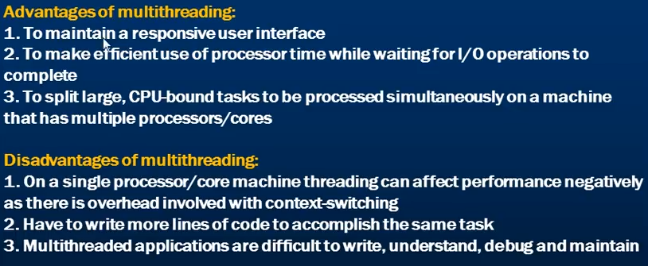

# ThreadStart Delegate

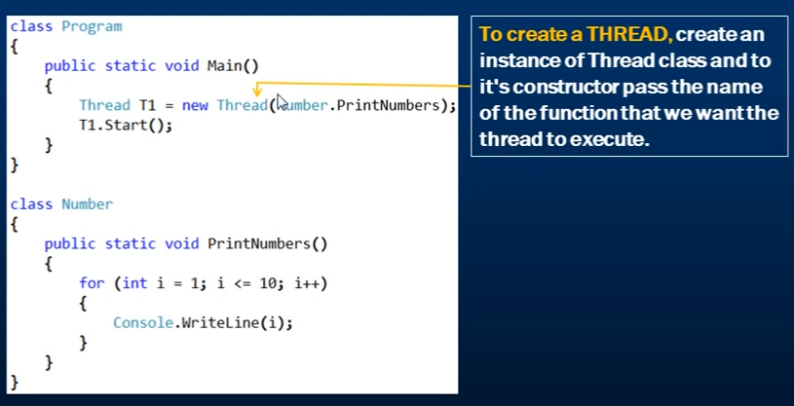

The constructor of a Thread class has 4 overloaded versions. The second one asks for a ThreadStart delegate as a parameter.

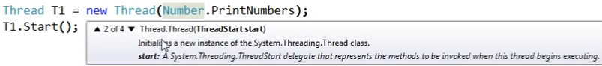

So lets use the ThreadStart delegate to achieve the same



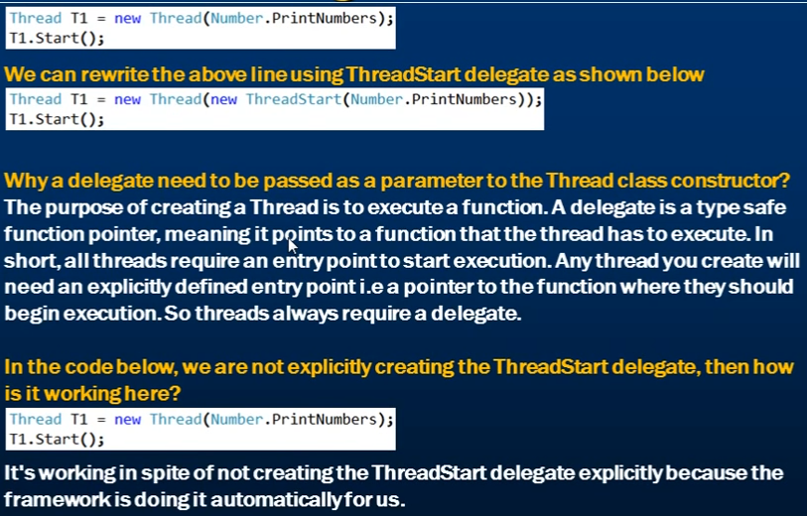

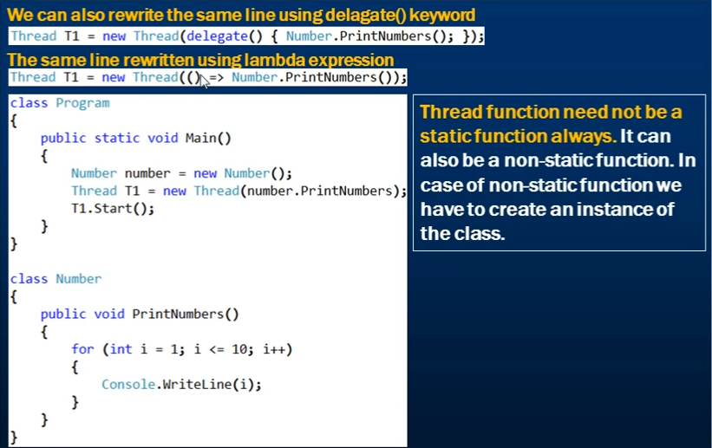

# Parameterized ThreadStart() delegate

Use this delegate if you need to pass data to a Thread function.

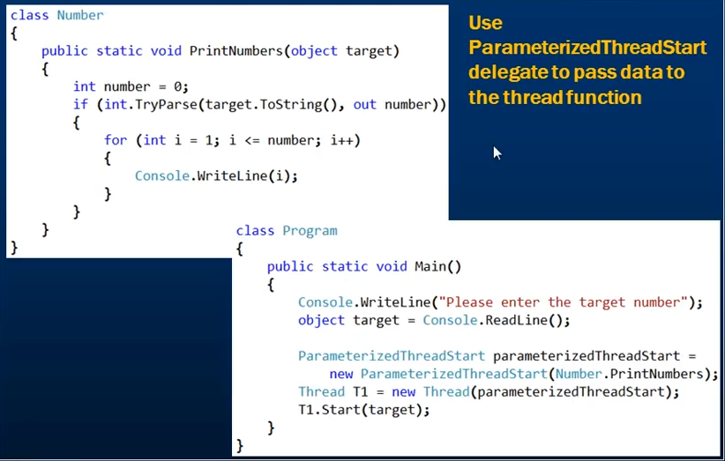



The signature of ParameterizedThreadStart delegate takes in a parameter of object type. This is why the PrintNumber method parameter need to be of object type for this to work.

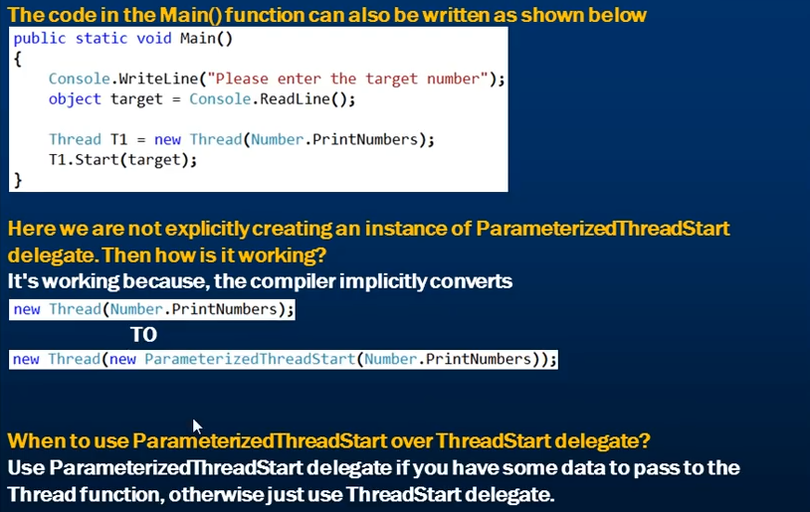

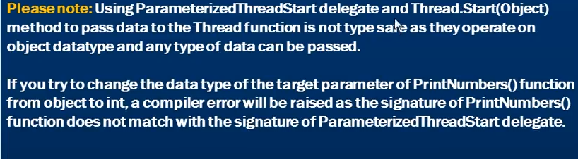

# Passing data to the Thread function in a type safe manner

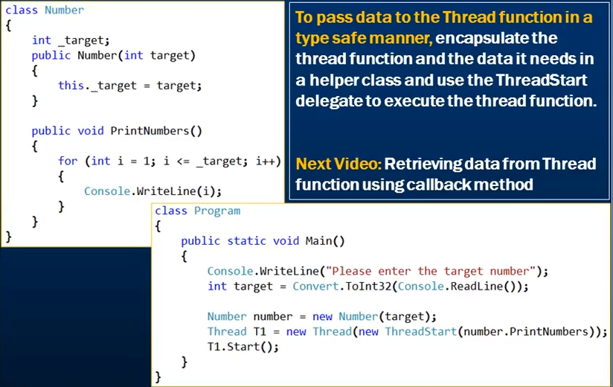

# Retrieving Data from a Thread function using the callback method.

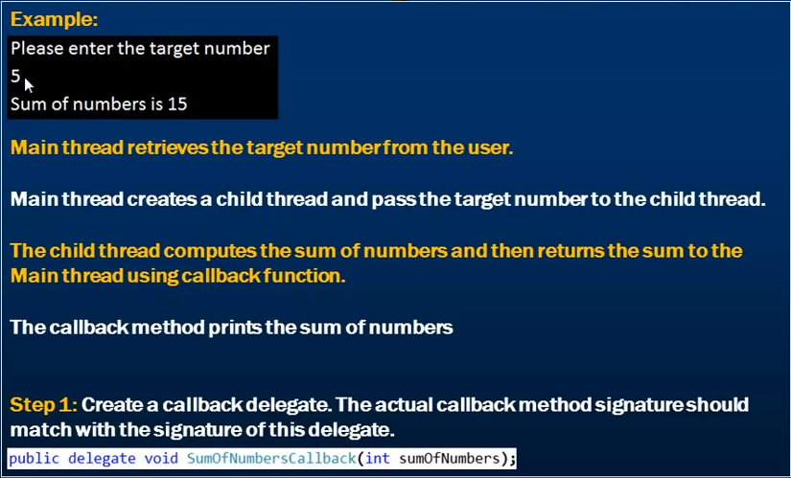

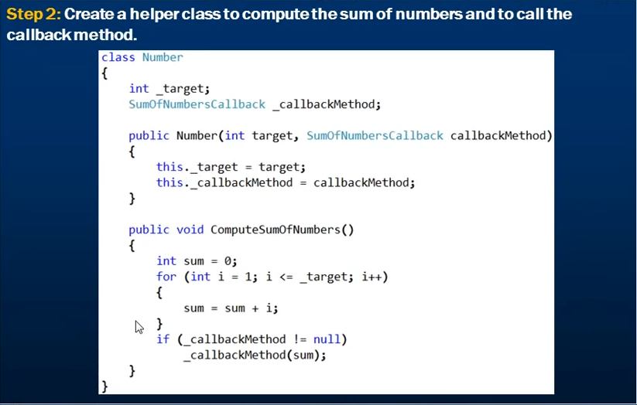

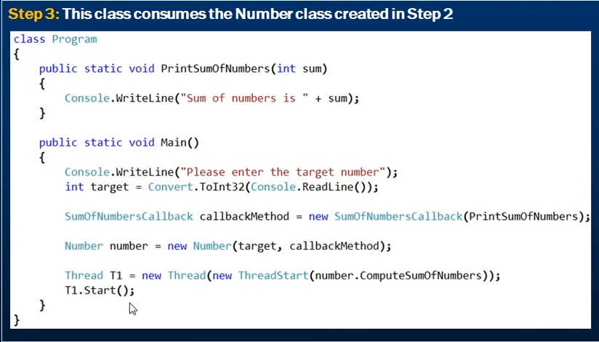

# Thread Join and Thread IsAlive() functions

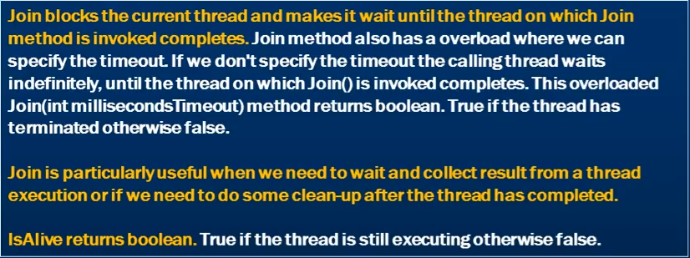

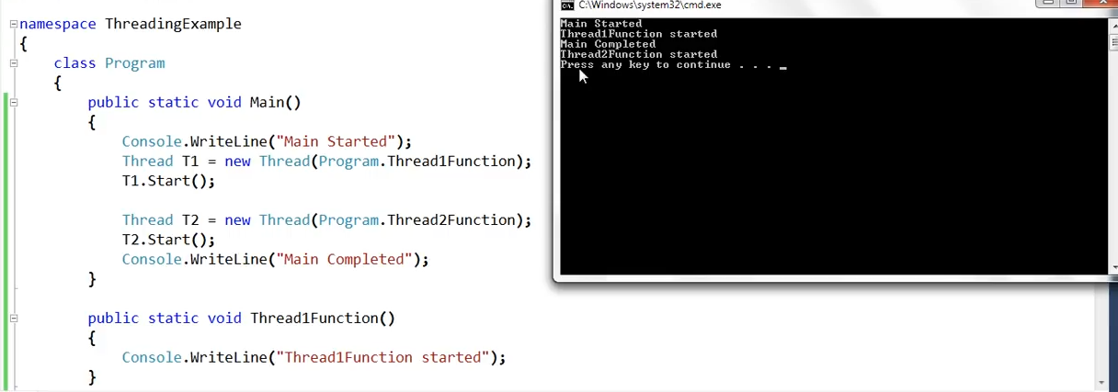

Notice the output. Main completed message is printed before the thread 2 started.

This is because when the program starts we get a main thread which starts executing the program and prints the first message of main started.

It then starts creating Thread1 and Thread2 without waiting for them to finish. So, in this scenario by the time the Thread1 completed, Main thread also got completed and so the message sequence. The Thread2 completed after the main thread processing is done.

Sometimes, we may need to make the main thread wait while worker threads are doing their work probably because we want to collect the results of the worker threads and then based on that we want the main thread to do something.

This is when the Join is particularly useful. If you run the above program again, chances are that you might see the output message differently.

So, if we want our main thread to wait for all the worker processes to finish then we will have to use the join method.

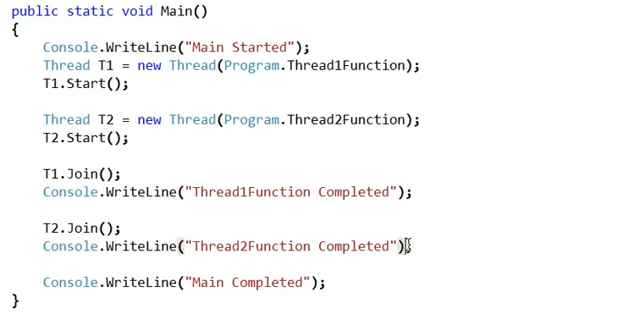

T1.Join() signifies the joining of Thread1 to the Main thread and once the T1.Join() line is execution, the program will suspend the execution of Main thread and wait for the Thread1 to complete. Similarly for Thread2.



Now despite of how many times we run the above program, we get the same output.



There is another overload of the Join() method which takes in a millisecond timeout. This is the time for which the main thread is going to wait for the Thread to complete or return otherwise the Main thread will resume its execution. This overloaded version returns true if the method returns before the timeout specified or else false.

# Protecting Shared resources from concurrent access in Multithreading.

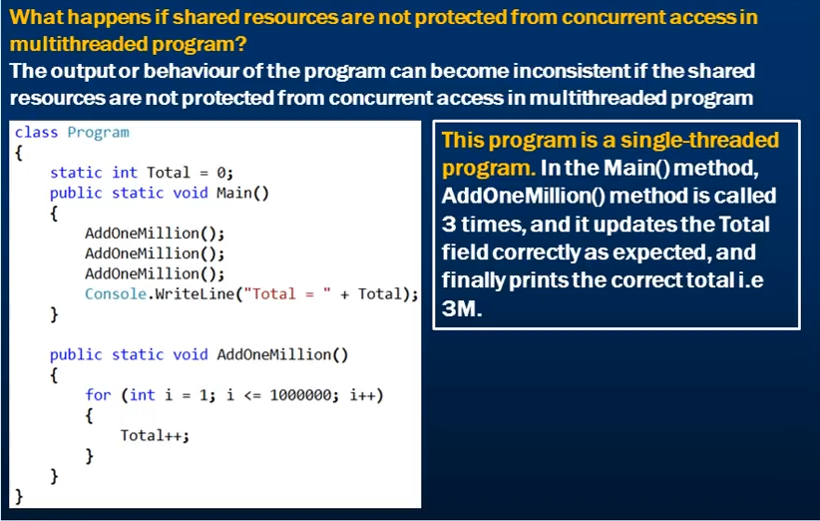

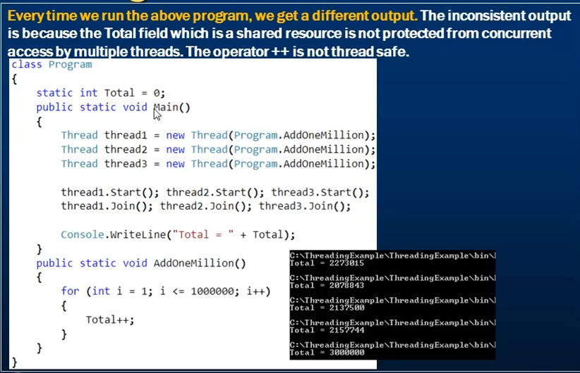

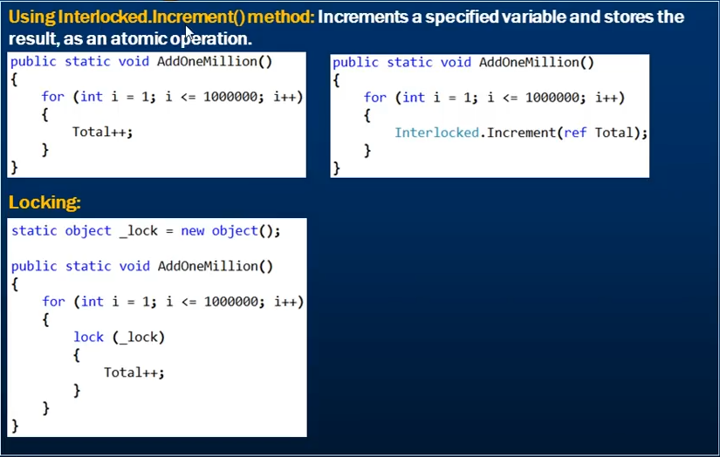

When we use lock only one thread can enter that portion of code at a time.

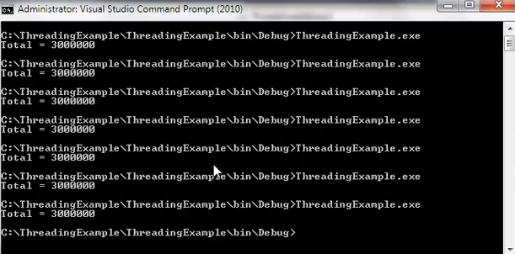

Doing so, we get the same output everytime.

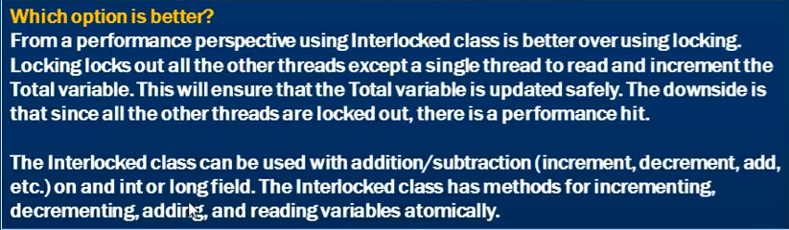

# Monitor v/s lock

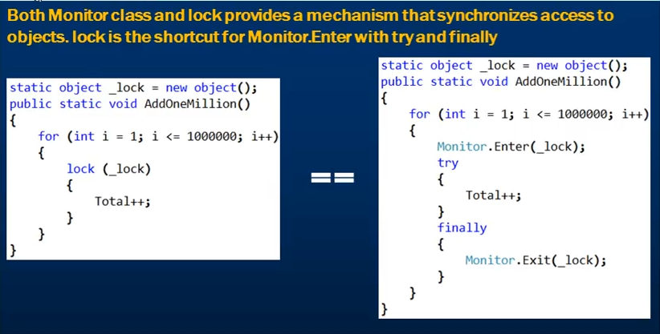

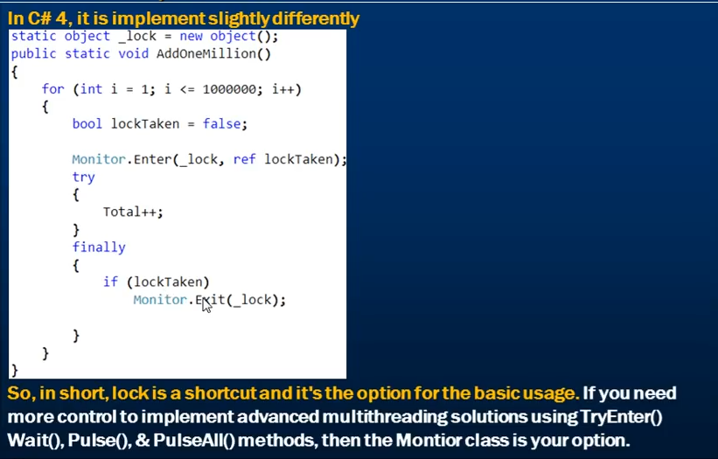

# Deadlock in Multithreading

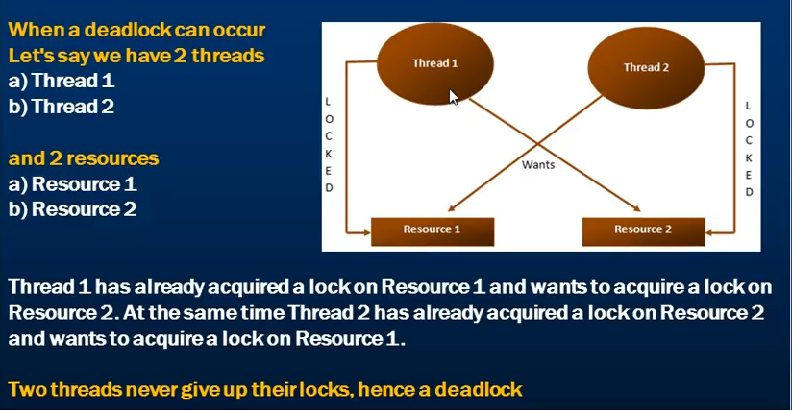

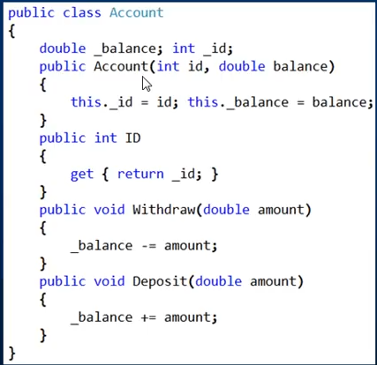

Below AccountManager class is responsible for transferring funds between one account to another.

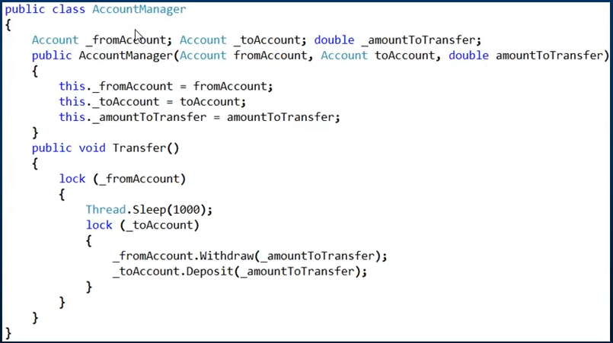

Notice that we are acquiring a lock on the from account and the to account. Now suppose that one thread has acquired lock on the from account and in the mean time another locked the to account, in that case the first thread will wait for acquiring lock on the to account and a deadlock can occur.

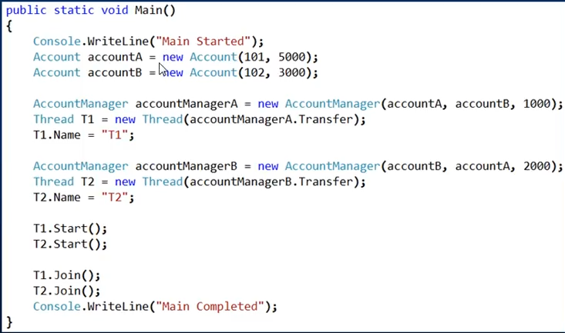

We have two accounts with Id 101 and 102 with a balance of 5000 and 3000 respectively.

Then the thread1 tries to transfer 1000 from 101 to 102

Thread 2 tries to transfer 2000 from 102 to 101.

We start both the threads and then join both threads with the main thread.

Since there is a sleep of 1 second between the lock of from account and lock of to account, so when the first thread has acquired lock to the account 101 and wait for 1 second, thread to has acquired a lock to account 102 which is a from account for the thread 2. Now when the thread 1 will try to acquire a lock on the to account which is 102 for it, a deadlock will happen.

The message “Main completed” will never be reached.



Resolving deadlock via acquiring lock in a specific order

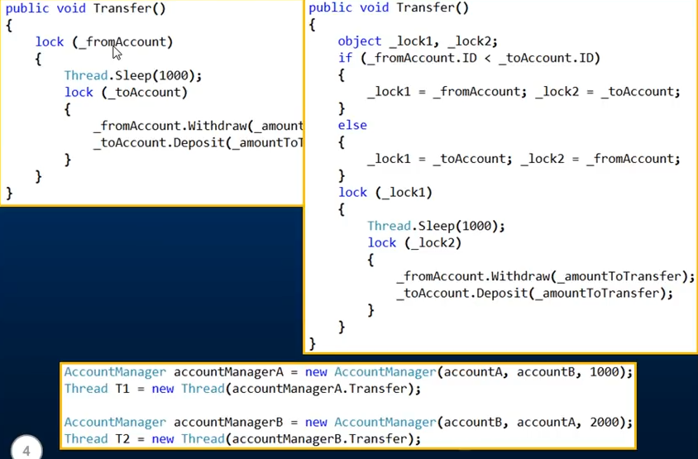

What happens now is,

Thread1 tries to transfer 1000 from account 101 to 102

Lock1 = 101 and then goes to sleep for 1 second. Lock2 = 102

Thread 2 tries to transfer 2000 from 102 to 101. Now when the thread1 is asleep, for thread 2 lock1 = 101 and lock2 = 102

Since lock1 is already locked for 101 and is used by thread1, thread2 will not be able to acquire lock on 101. After thread1 is resumed from sleep and acquires lock on 102 through lock2, transfers the amount and releases the lock. T2 gets a hold on 101 and then 102 and then transfers the amount.

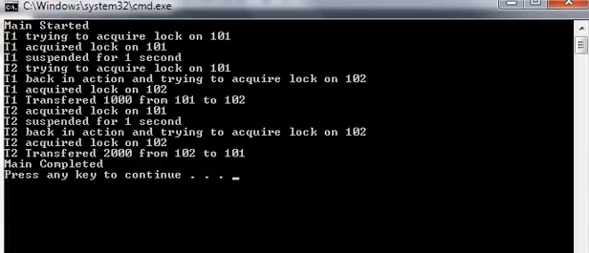

Notice the order in which the lock is acquired. Both the threads acquires lock on 101 first and then 102.

# Performance implications of a multithreading application

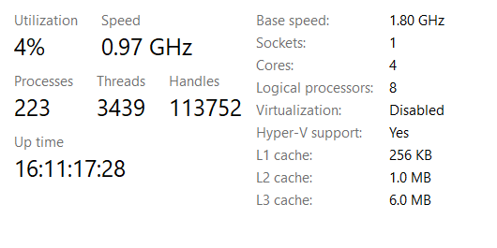

Notice that I have 4 core and 8 processor. Since I have 8 processor, 8 threads can be simultaneously executed.

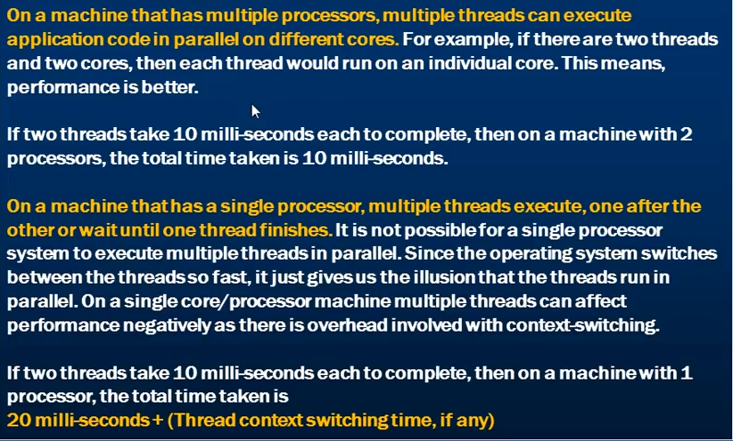

# Anonymous methods

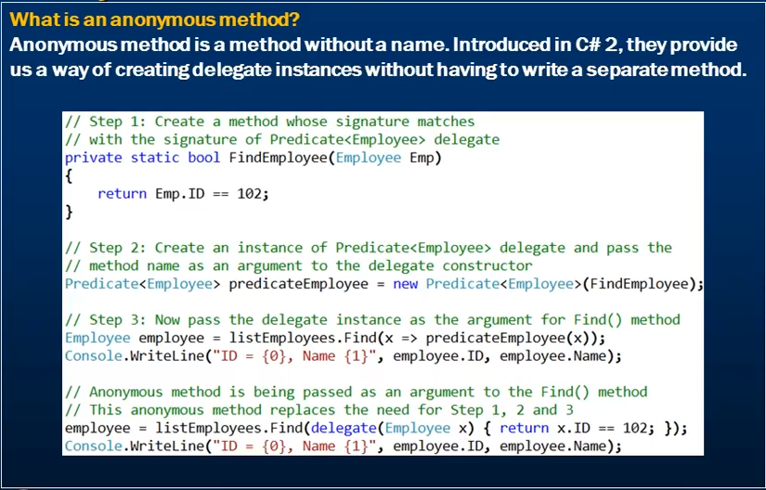

Currently we have an Employee class with Id and Name fields and a list of employees

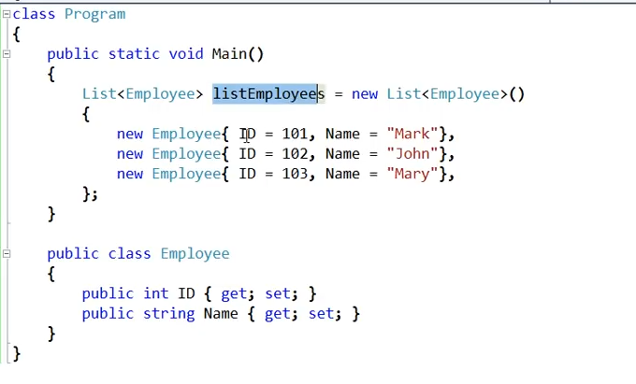



The List<Employee> has a Find() method on it which takes in a Predicate.

Definition of Find method



And if we see the definition of Predicate, we see that it is a delegate.

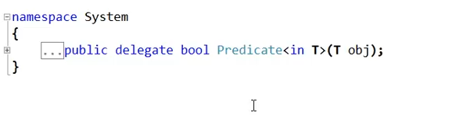

It expects a type T as a parameter and returns Boolean. In our case T is employee.

So, we need to pass a delegate pointing to a function similar in definition with the Predicate delegate into the Find method. In order for a delegate point to a function, in the delegate constructor, we pass the name of the function.

So, we need to create a function that the delegate can point to. The signature of the function should be similar to that of the Predicate delegate. So let’s create a function.

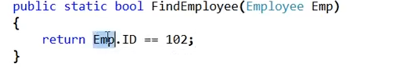

Now let’s create an instance of the Predicate delegate and pass it our function. Then we pass the delegate instance to the Find() method of the list<Employee>.

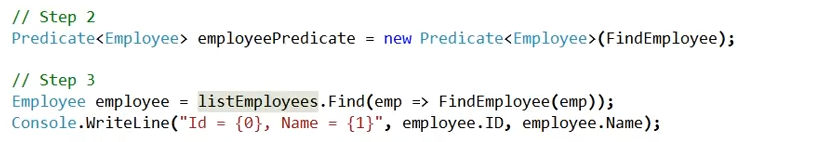

Now this is one way and is not an anonymous method approach. As we know that anonymous methods are methods without name and here we created a method.

Instead of all these, we can achieve the same in one line with anonymous methods.

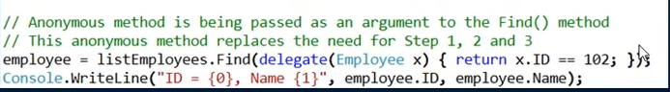

So this is an anonymous method. You use the delegate keyword for creating anonymous methods. Notice that it does not have a name and just has the body implemented in curly braces.

Anonymous methods are also useful if we are subscribing to an event handler.

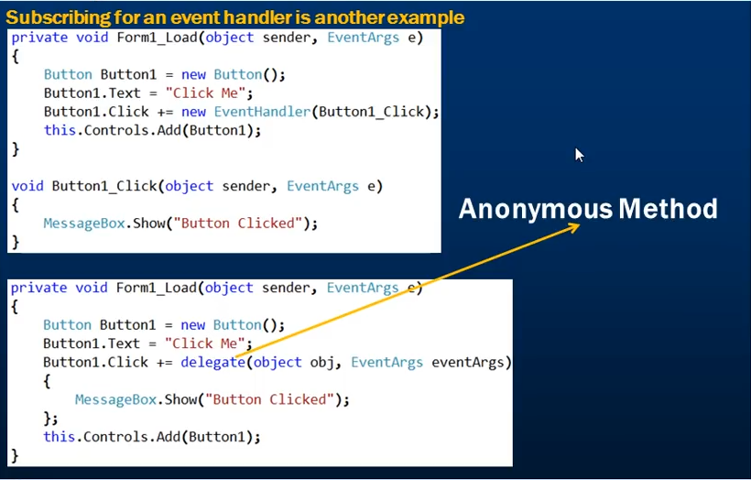

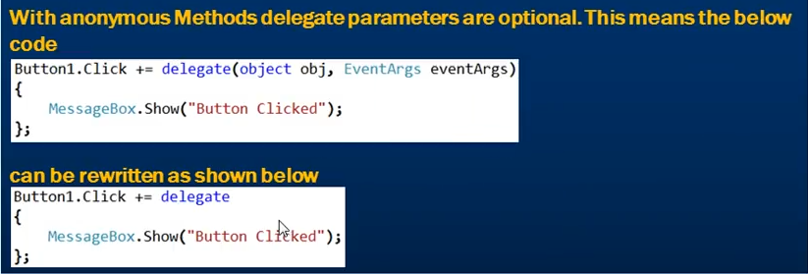

# Lambda Expressions

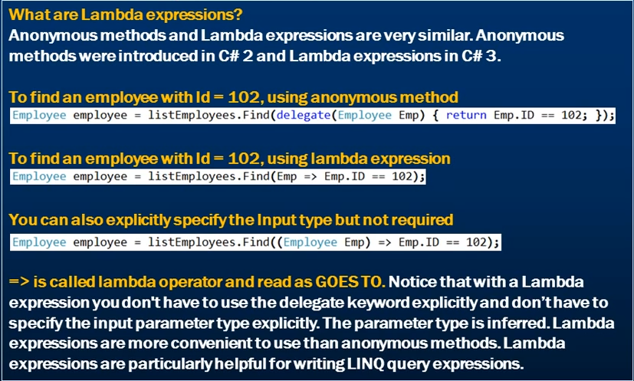

Lambda expressions supersede anonymous methods.

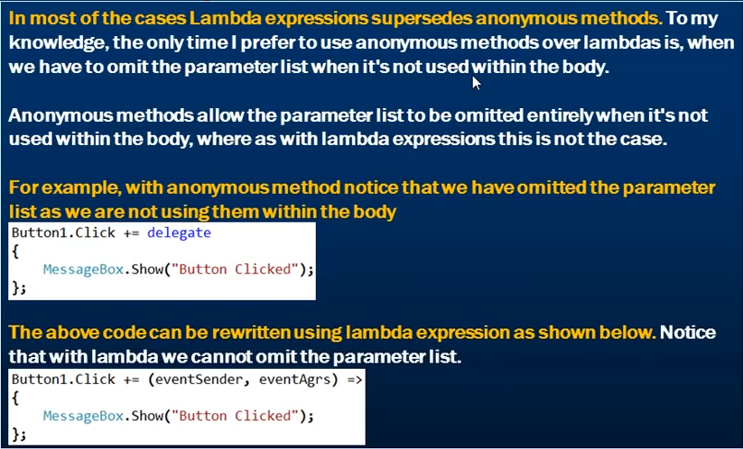

# Func delegate

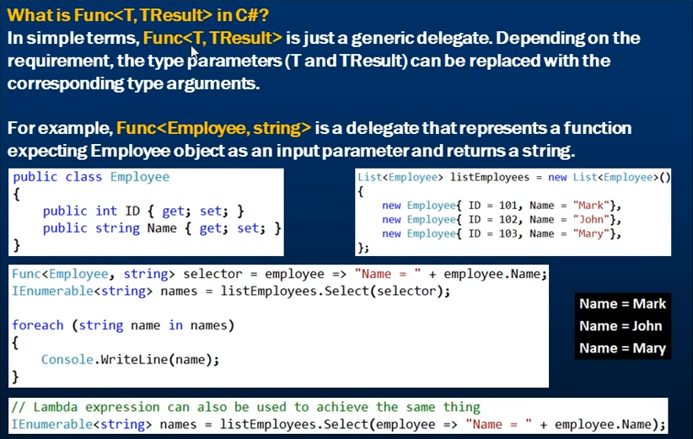

The Func delegate takes in 2 parameters, T which is an input parameter and TResult is the parameter the delegate is going to return

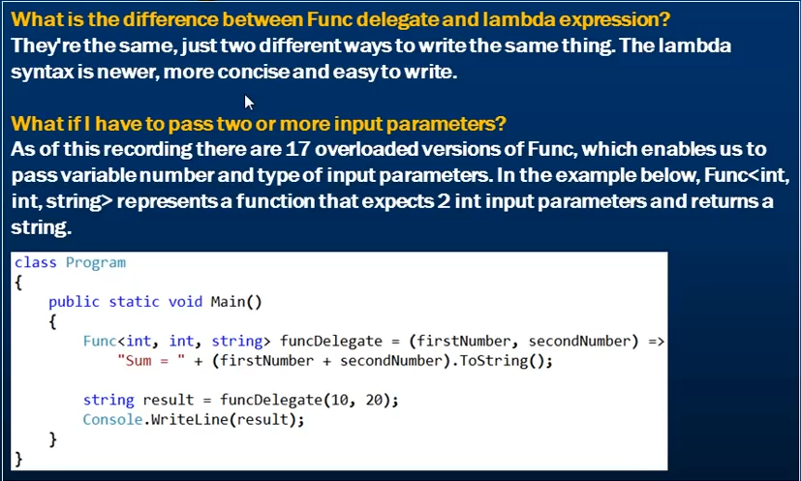

# Async and Await

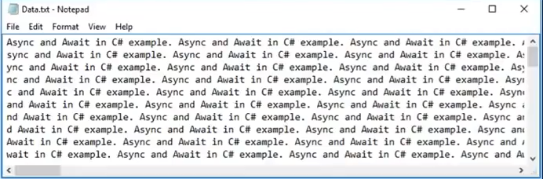

Let’s say we have to read the file and count the number of characters in the file. Let’s also assume that the file is very big and it takes almost 5 seconds to count the total number of characters.

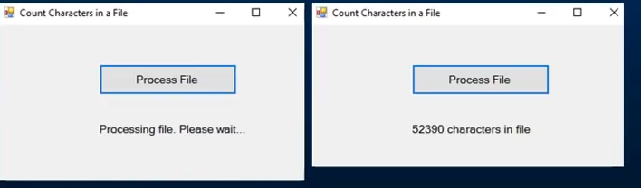

We also want to display these messages when we click the Process file button. The application should be responsive during the time it is processing the file and should not hang. We should still be able to interact with the application during the processing time. We should be able to move the form around or resize it.

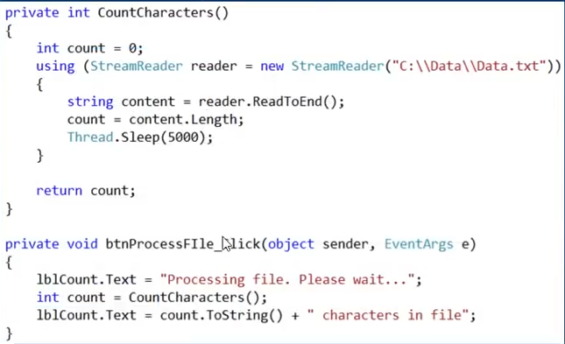

This is the method responsible for counting the characters in the file. When we run this, we will not be able to move and resize the form until the button has finished what it was doing.

This is where Async and Await comes handy.

1. We will mark the method btnProcessFile as async using the async keyword.
2. Then we will use the Task class present in System.Threading.Tasks namespace to call the CountCharacters method. Since the method takes some time to count, we are offloading the responsibility to the Task class.

So, while the task is busy in executing the method and counting the characters in the file, the UI is free and we will be able to move and resize the form.

1. Lastly, when the application is about to finish, just before that we need to wait for the Task to finish. This is where we are going to use the await keyword.

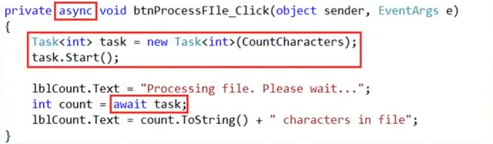

The async keyword signifies that the method is an asynchronous method and the await keyword specifies a suspension point. The await operator signals that the async method can’t continue past that point until the awaited process is completed. And in the meantime, control returns to the caller method.

Note here that the absence of the await operator doesn’t cause a compiler error.

# Wait for thread to finish without blocking.

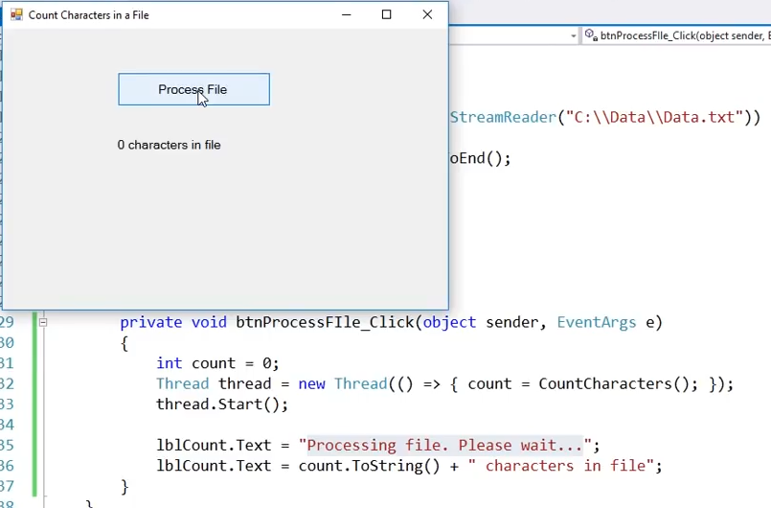

Notice that we have removed the async and await from the code and are using the thread to call the CountCharacter function instead of the task.

When we run this, we first do not see the “Processing File” message and see the count of characters as 0.

This happened because the main thread is creating a worker thread with name as thread which is going to count the characters. The worker thread is going to take 5 seconds to complete. In the meantime, the main thread will continue to execute the next two lines of code.

Now the main thread executes the 2 message display lines of code so fast the we do not see “Processing file” message. Since the worker thread is still running and the count variable is not updated, the out is shown as 0 characters in file.

To fix this problem, all we have to do is make the main thread wait for the worker thread to finish before we can display the second message. To wait for the worker thread, we use the Join() method on the worker thread.

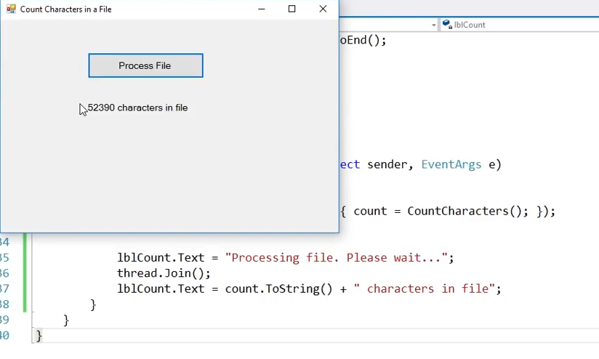

While this solves all our previous problem, we have introduces a new problem and that is blocking the UI. The time for which the application is busy processing the file, we will not be able to interact with the application. This means that we cannot move and resize the form while the application is busy.

To solve this,

1. We need to remove the Join() method call as this is what is blocking the application as because of this our main thread is waiting for the worker thread to finish first.
2. We need to update the result in the worker thread itself.

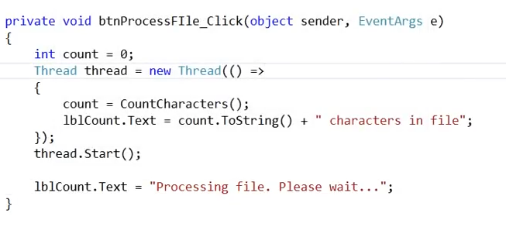

This solves our blocking issue.

But this is not the right way to achieve this. As far as multithreading is concerned, there is one important rule to keep in mind which is the thread that has created a control should only be modifying its properties. No other thread should be doing that. So, only our main thread should be modifying the label text and not the worker thread.

So, the right way to do is by using the Begin – Invoke method. The Begin – Invoke method is going to ask the Ui thread/ main thread to set the label control text property.

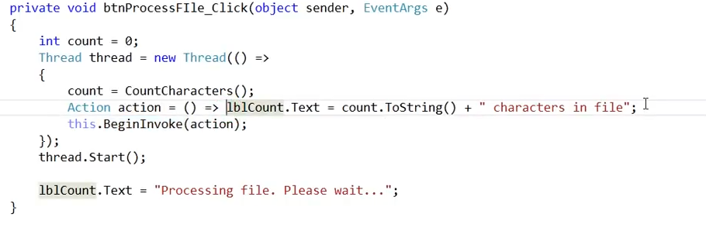

Now the BeginInvoke method is going to ask the main thread to execute the Action line code asynchronously in a type safe manner.

To make the action delegate to point to the piece of code that we want to execute, we are making use of lambda expression here. We can rewrite this by creating a function and then pointing the delegate to it.

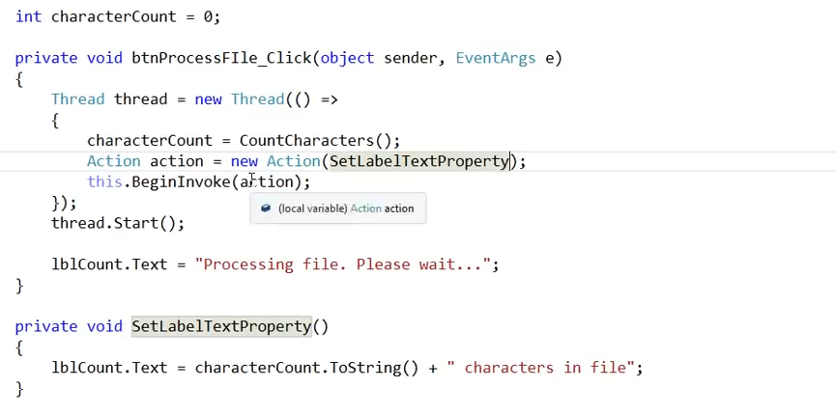

This above code is very complicated for just a simple task which we were easily able to do using the async, await and Task.